Curriculum Vitae
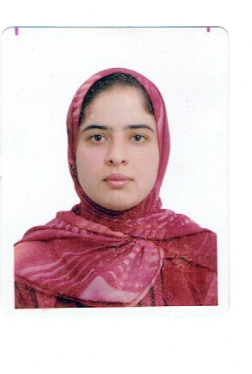
Full Name : Zhwan Hamadamin Abdullah
Marital Status : married
Date of Birth : 15/2/1986
Nationality : Kurdish
Address :Choman
Telephone (Mobile) : 07504322898
E-mail : zhwanhawlery@ymail.com

Academic Qualifications

Year  From – To | Specialization  Major/ Minor | Faculty (College) | University / Institute | Degrees  (PhD, MSc, PGDiploma, BSc)
2003-2005 | Social dept. | social | Teacher institute | Diploma
2005-2008 | Law | law | Koya University | BSc

Professional & Training Courses

Place , Authority | Field | Course Description | Year
Choman | Education | English course | 2011

Committee Appointment

Accountability | Title of Committee | Name of Institution (Faculty) | Year
member | Examination Commission | Choman Technical institute | 2010-2012
Head | Summer training | Choman Technical institute | 2011-2015
Head | Students acceptance | Choman Technical institute | 2013

Computer Skills

1- Word
2- Excel
3- Power Point

Employment Record

1.
Name and address of employer  Ministry of Education | Dates of employment ( Month , Year )  From 15/9/2005
Name and title of immediate supervisor | Teacher
Duties
1)Teacher (6 years)
2

Name and address of employer  Ministry of High Education and Research | Dates of employment ( Month , Year )  From :11/10/2010
Name and title of immediate supervisor

Duties
- Head of labour administration department (4 years )
- Coordinator of cusgtom administration department (2 years )

