TABLE OF CONTENTS

Curriculum Vitae
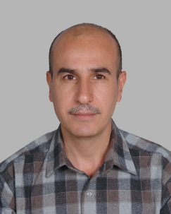
Personal Information:
Name: | YakawHamad Abdullah
Address: | Iraq,Erbil,Koya,House No: 73 Shahedan
Contact: | 009647502383885
E-mail: | Yakaw.hamad@epu.edu.krd
Place of birth: | Iraq – Erbil – Koya
Date of birth: | 27 December 1971
Nationality: | Iraq
Race: | Kurdish
Sex: | Male
Marital status: | Married

Languages:
Kurdish: | Mother Tongue.
Arabic: | Good.
English: | English –Writing (excellent), speaking (good).

Qualifications:

1993-1994 : | Diploma in Accounting in Erbil Technical Institute stood third in the list.
2006-2007: | BA in Financial and Accounting in Sulaimani Polytechnic University, stood forth in the list.
2013-2014: | Master in Accounting in Bharati Vidyapeeth Deemed University, Yashwantrao Mohite Collegein the India.

Other Skills:

IT Skills: | Windows, MS Office (Excel, Word, Power Point) Internet.
Sporting Interests: | Football, Swimming and Mountain Climbing.
Hobbies: | Reading, Drawing. Pet breeding

Employment to Date:
Ministry of Higher Education & Scientific Research, Erbil Polytechnic University, Kaya Technical Institute from December 1997.

Training courses:
2007: | Financial and accounting course in SulaimaniTechnical Institute.
2010: | contract and tenders hold by USAID.

Professional experience:
2008-2010: | work as an Accounts manager.
2010: | Work as an Auditor.

Administration Experience:
2010-2011: | Assistant Head of the Business Administration Department.
2011-2012: | Assistant Head of accounting Department accounting.
2015 to date: | Head of accounting Department .
Teaching Experience:
2009-2010: | Teaching Computer Applications .Excel.
2009-2011: | Teaching Principles Of Accounting in Department of Business Administration
2015-2016: | Teaching Principles of Accounting in Accounting Department.
2009 To Date: | Teaching Specialized Accounting in Accounting Department.
2014 To Date: | Teaching Intermediate Accounting, Specialized Accounting and Tax Accounting in University of Kaya, in Accounting Department as Lecturer.

