Curriculum vitae |  | Contact Information  phone: (0750) 4547708  venossaeed@epu.edu.iq  venossaed@yahoo.com
PERSONAL | Name: Venos Saeed Abdullah  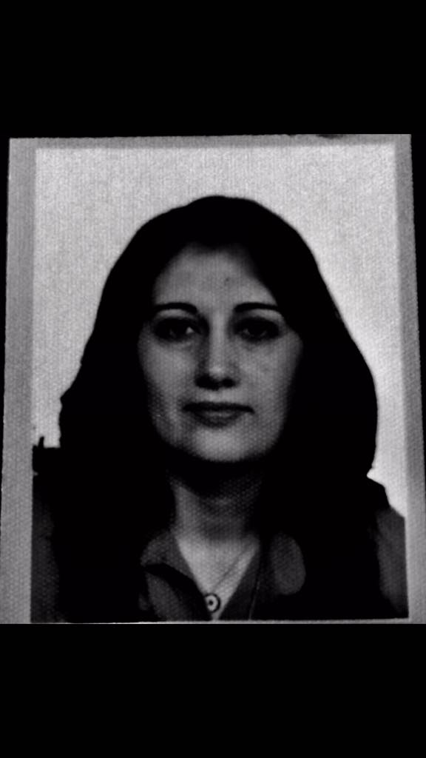  Birthday: 10/ September / 1973  Place of Birth: Erbil, Iraq  Citizenship: Iraqi  Marital Status: Single  Visa Status: Permanent Resident
EMPLOYMENT | Ministry of higher Education Scientific Research / Erbil Polytechnic University - | Erbil Health Technical College  - Teaching Biochemistry since 2006  - Teaching Professional ethics 2013, 2014
EDUCATION | Salahaddin University, Erbil , Iraq  Education college / chemistry department  Master of organic chemistry  September 2014-2016  Thesis: Synthesis and characterization of a new series of aryliden compounds .  Salahaddin University, Erbil, Iraq  Education college / chemistry department  Diploma chemistry / 2008-2010
SKILLS | Interpersonal Skills:  - Good Communication Skills.  - Work under-Pressur  - Effectively Participating in teamwork and sharing Knowledge and Ideas.  - Formulating Questions and Collecting Data.  - Networking.  Language Skills:  - Fluent in Kurdish (Spoken, Read, Written).  - English (Spoken, Read, Written) at very Good Level.  - Arabic (Spoken, Read, Written) at very Good Level.  Computer Skills - Microsoft Office, Excel, and PowerPoint.

