**Introduction to physiology**

**Physiology:** is the science of the *function* of living systems. This includes how organisms, organ systems, organs, cells and bio-molecules carry out the chemical or physical functions that exist in a living system. The highest honor awarded in physiology is the Nobel Prize in Physiology or Medicine, awarded since 1901 by the **Royal Swedish** Academy of Sciences.

**The science of physiology include the following systems:**

1-Circulatory system; (hematology & cardiovascular physiology).

2-Gastrointestinal system; (gastrointestinology).

3- Urinary system;(nephrology).

4-Respiratory system; (pulmonology).

5-Nervous system;(neurology).

6- musculoskeletal system;(musculoskeletal physiology).

7-Endocrine system; (endocrinology).

8-Immune system;(immunology).

9-Integumentery system;(dermatology).

10-Reproductive system;(sexology, embryology).

**Structure of living organism:**

*Cell*: the simplest structure that can perform all living functions, which is the functional unit of all living organisms . There are two types of cells :

1. *Prokaryotes* : simplest organism composed of one cell for e.g. bacteria .
2. *Eukaryotes* : organism composed of many cells for e.g. human cells .

*Tissue*: cells working together to perform certain specific function.

*Organ*: tissues working together to perform certain specific function.

*System*: organs working together to perform certain specific function . there are two types

**Cytology:** is the study of the functions and different characteristics of the cells.

**Histology**: is that science which deals with the tissue structure and functions.

**Levels of Organization:**

**CHEMICAL LEVEL** - includes all chemical substances necessary for life (see, for example, a small portion - a [heme group](http://cwx.prenhall.com/bookbind/pubbooks/hillchem3/medialib/media_portfolio/text_images/CH25/FG25_07.JPG) - of a hemoglobin molecule); together form the next higher level.

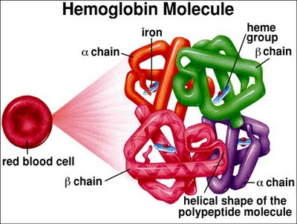

**CELLULAR LEVEL** - cells are the basic structural and functional units of the human body & there are many different types of cells (e.g., muscle, nerve, blood, and so on)

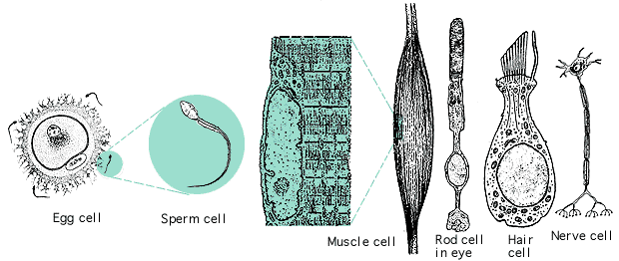

[**TISSUE**](http://www.emc.maricopa.edu/faculty/farabee/BIOBK/BioBookAnimalTS.html) **LEVEL -** a tissue is a group of cells that perform a specific function and the basic types of tissues in the human body include epithelial, muscle, nervous, and connective tissues

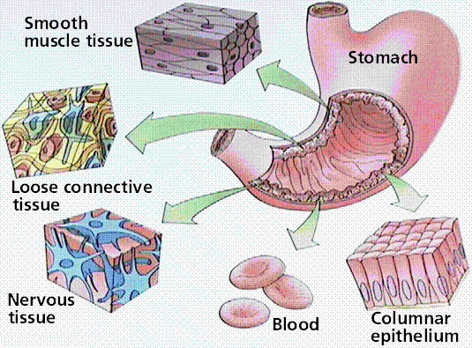

**ORGAN LEVEL** - an organ consists of 2 or more tissues that perform a particular function (e.g., heart, liver, stomach, and so on)

**SYSTEM LEVEL** - an association of organs that have a common function; the major systems in the human body include [**digestive**](http://arbl.cvmbs.colostate.edu/hbooks/pathphys/digestion/basics/anatomy.html)**,** [**nervous**](http://www.emc.maricopa.edu/faculty/farabee/BIOBK/BioBookNERV.html)**,** [**endocrine**](http://www.emc.maricopa.edu/faculty/farabee/BIOBK/BioBookENDOCR.html)**,** [**circulatory**](http://www.emc.maricopa.edu/faculty/farabee/BIOBK/BioBookcircSYS.html)**,** [**respiratory**](http://www.emc.maricopa.edu/faculty/farabee/BIOBK/BioBookRESPSYS.html)**,** [**urinary**](http://www.geocities.com/CapeCanaveral/Launchpad/5172/urinary.html)**,** and [**reproductive**](http://www.emc.maricopa.edu/faculty/farabee/BIOBK/BioBookREPROD.html).