Curriculum vitae |  | Contact Information  phone: (0750) 4236395  tahseenabda2002@yahoo.com
PERSONAL | 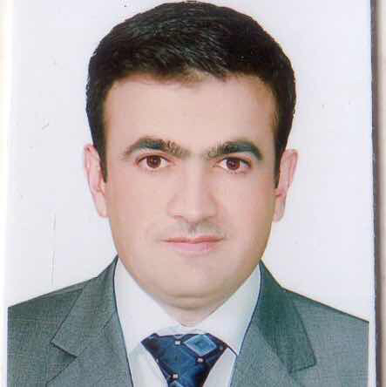  Name: Tahseen Abdah Abdullah  Birthday: 1/ January / 1978  Place of Birth: Erbil, Iraq  Citizenship: Iraqi  Marital Status: Married  Gender :Male  Race : Kurdish  Religion : Muslim  Visa Status: Permanent Resident
EMPLOYMENT | Ministry of higher Education Scientific Research /Erbil Polytechnic University - Medical Technical Institute| Erbil  - Worked as a assistant biology since my graduation (2001-2002)and I have taught (physiology, bacteriology, parasitology, microbiology and biostatics)  - I have been teaching (physiology and biostatic) since 2010.  - I have been working in quality assurance since 2011.
EDUCATION | - Varonezh University, Varonezh city, Russia  Master of Histophysiology  July- 2010  - 2001- 2002 B.Sc. Biology, University of Salahaddin, Iraq
TRAINING  &  PROFESSIONAL  DEVELOPMENT | Participation in Workshops & Meeting:  - Attending course about First aiding at polytechnic university- Erbil Technology Institute, department of reseraching. For 3 days 2016.  - Attending prevention of eye disease work shope in Erbil medical institute .  - Attending quality assurance work shope in Erbil medical institute .  - Attending laboratory medical instrument in Erbil palace .  - Foregoing Lecturer at Soran Technical Institute 2011 to 2014.  TEACHING EXPERIENCES  - Taught micro-technique in Soran institute from 2011 to 2012.
SKILLS | Interpersonal Skills:  Language Skills:  - Fluent inKurdish (Spoken, Read, Written).  - Russian (Spoken, Read, Written) at Good Level  - Turkish (Spoken only).  - English (Spoken, Read, Written) at Good Level.  - Arabic (Spoken, Read, Written) at Good Level.  Computer Skills - Microsoft Office, graph pad, Excel, and PowerPoint.  Teaching skills – I have been skilled in teaching and Researching.

