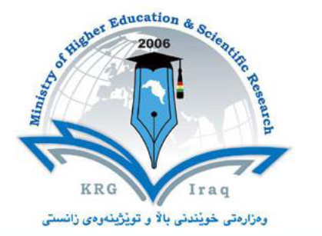 |  |  | Curriculum Vitae  Questionnaire |  |  |  |  |  |  |  | KURDISTAN REGION GOVERNMENT  Ministry of Higher Education &  Scientific Research
Family Name/Surname | Berzengy |  |  |  | First Name |  |  |  | Sawsan |  |  |  |  | Middle Name |  |  |  | Aziz Abdullah
(Home address Optional) |  | Erbil / Nergiz
Postal Address
E-mail |  | physiosaw@gmail.com
Tel. No. (Optional) |  | +9647504901887
Date of birth |  | 1-7-1979 |  | Place of birth |  |  |  | Iraq / Erbil
Preparatory graduated from |  | Kurdistan |  | Govern orate |  |  |  | Erbil |  |  |  | Year |  |  |  | 2002-2003
Date of first assignment in University |  | 11/8/2003 |  | Place of recent work |  |  |  | Erbil polytechnic university |  |  |  | Job title |  |  |  | Lecturer
 |  |  |  | Academic title |  |  |  | Assistant Lecturer |  |  |  | Tel. No |  |  | +9647504901887
Researcher’s academic attainments |  | Type of diploma |  | University |  |  | College |  |  | Department |  | Graduation year |  |  |  |  | Country\ Govern orate
 |  | B.Sc. |  | Salahaddin |  |  | Science |  |  | Biology |  | 2001-2002 |  |  |  |  | Iraq/ Hawler
 |  | M.Sc. |  | Salahaddin |  |  | Science |  |  | biology |  | 2006-2008 |  |  |  |  | Iraq/ Hawler
General specialization |  | Biology
Specific specialization |  | Physiology
Academic titles attained |  | Academic title |  |  |  |  |  |  |  |  | Date of attainment
 |  | Assistant Lecturer |  |  |  |  |  |  |  |  | 27/11/2008
 |  | Lecturer |  |  |  |  |  |  |  |  | 22/5/2017
Language skills

Name of language |  |  |  |  |  | Good |  |  |  |  |  |  | Fair
Kurdish |  |  |  |  |  | x
Arabic |  |  |  |  |  | x
English |  |  |  |  |  | x

Assignments and posts

Assis. Head Dept.

Number of Presented thesis\ researches = 4

1- Effects of L-arginine, Simvastatin and Melatonin on Some Biochemical parameters in Hyperglycemic Male Albino Rats.

2- Effects of Simvastatin and Melatonin on Some Biochemical parameters in Pinealectomized-Hyperglycemic Male Albino Rats.

Role of Metformin in the Treatment of Female Infertility with Polycystic 3-
Ovary Syndrome (PCOS) in Erbil City

4- Metabolic Syndrome in Overweight Kurdish Women.

