**Summary :**

My name is **Salim Azeez Kako** , I am 60 years old living in Erbil.

I am college lecture , I would like to offer my services with everyone to produce the best products for the market and human services .

**Skillhighlights :**

* **Microsoft Excel**
* **Microsoft PowerPoint**
* **Microsoft Word**
* **Office laboratory program and spps program for research**

**Experiences :**

* Education
* steel mining
* terrazzo tile , animal feeding , flour company
* volunteer activates

**Educations :**

* **BSc. engineering metallurgy 1982**
* **MSc. engineering metallurgy 2003**

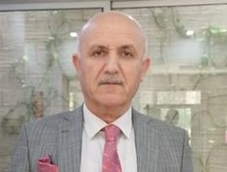

**Contact**

**Address :**

**Erbil – Zanko 2**

**Phone :**

**00 96475044910895**

**Gmail: salim.kako@epu.edu.iq**

**Languages**

* **Kurdish**
* **English**
* **Arabic**
* **very good listener**
* **public speaking skills**

**Hobbies :**

* **Sport**
* **Reading**
* **Waking under water**