Salar Ismail Ahmed
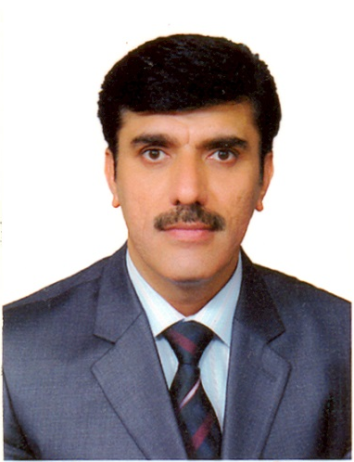
Erbil
Kurdistan Region
Iraq
Salar.ahmed@epu.edu.iq
Mobile: 07504685776
Sex: Male
Nationality: Kurdish - Iraqi

- Education:
1. MSc in: Electrical and Electronic Engineering Eastern Mediterranean University, September 2014. Gazimağusa, North Cyprus.
2. BSc in: Electronic and Control Engineering at Kirkuk Technical Engineering College (2006).
3. Diploma in: Electronic Department at Baghdad Technical Institute (1987).

- Professional Training:
Microsoft office, Power Point, Excel, MATLAB and Auto CAD, Comsol Multiphysic

- Professional Registration:
Me member ship of Kurdistan region Engineering syndicate and me member ship of Iraqi Engineers Union with degree of MSc - Licentiate.

- Languages:
Kurdish, Arabic & English

- Professional Experience:

Ministry Of Education, Erbil – Iraq, Oct 1995 – Oct 1999.
Position: Lecturer in Electronic Industry Secondary school.

Ministry of Higher Education and Scientific Research, Foundation of Technical
Education, Erbil Technical Institute - Electrical Department, Erbil – Iraq, Oct 1999
– Feb 2018.

Position: Head of Information Technology Department, 28th October 2018.

Position: Head of Electrical –Evening Department, September, 2017.

Position: Rapporteur of Road Construction Department, 2010-2012.
Position: Lecturer in Electrical Department, Power, Electronic and Communication
Branches.

Responsibilities:
Lecturing various modules including: Mathematics, Electronic Principles, Electric Circuits Maintenance of Communication Instruments, Electronic Devices, Computer Applications (AutoCAD), Power Electronics, Mobile Communication, Electrical Installation, and Students Project supervision.

