Personal Data
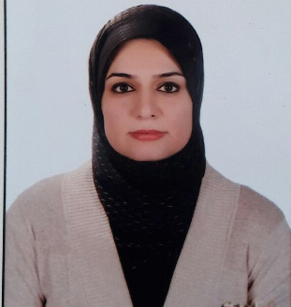

Name: Payman Mohammed Hasan
• Date & Place of birth: 1/1/ 1984 / Kirkuk
• Present Address: Mamostayani Zanko. / Erbil / Iraq
• Marital status: Married
• E-Mail Address: payman.hasan@epu.edu.iq

Languages

• Kurdish Mother Tongue
• Arabic Excellent
• English very good
• Turkish Medium

Social Activities

• Member of Kurdistan engineering Syndicate in Iraq.

Education

B.Sc. in Software Engineering in 2006.
Master in Software Engineering in 2017.

Certifications

English language proficiency: getting (5.5 in IELTS) on November 2019.

Experiences

• I participated in Cisco Networking Academy
• I worked in the laboratory of computer engineering at Erbil Technical College from 2009 to 2015.
• I have worked as assistant lecturer in business management department since 2019 till now.

