CV
Name: OMAR HASAN BASHEER
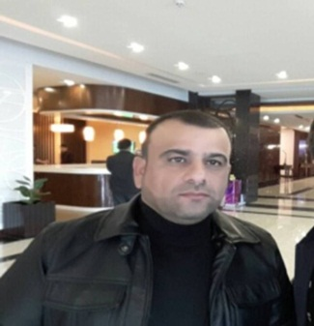
DOB: 01-07-1973
SEX: MALE
EMAIL ADDRESS: omar.bashir@epu.edu.iq
Mobile Number: 00964 (0)7701467332 - 00964(0)7515229373
Address: Iraq- Kurdistan Region- Erbil province- Koya District
Education:
M.A English Language and Literature 2014-2015 India
B.A English Language and Translation at Koya University for the study year 2007-2008
Diploma in Anesthesia at Erbil Technical Institute for the study year 1993-1994
Employment:
October, 7th 1997- present: work in Koya Technical Institute as teacher& Translator and also as a Registrar.
I work also with Koya Notary public office as a sworn translator for translating legal documents. My license No.: 2987 in 28-09-2009.
Language Skills:
Kurdish mother tongue, English, Arabic
Computer skills:
Microsoft Word, Excel

