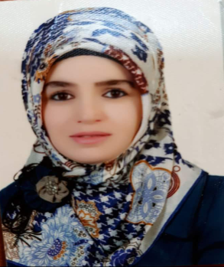
Nadia Farooq Sadeq
Address: Iraq, Kurdistan Region, Erbil
Birth date: 15/10/1990
Phone no.: +964 (0) 750 499 00 12
Specific E-mail: nadiasadeq2014@gmail.com
University E-mail: nadia.sadeq@epu.edu.iq
Marital Status: married
Nationality: Kurdish

Education
Bachelor degree in Science of soil and water, College of agriculture, Salahaddin University, Erbil-Iraq
1st rank by 82% (November 2008 – June 2011)
Master degree in soil Microbiology, College of agriculture, Salahaddin University, Erbil-Iraq
(November 2013 – June 2015)
Work Experience
- (2011 – 2012) work as assistant agriculture engineer in soil &water department/ salahaddin University-erbil.
- English proficiency course in English language center/salahaddin university (2012).
- Computer training course (ICDL) / salahaddin university-erbil (2012).
- Teaching method course/continuing education/ salahaddin university-erbil (2015)
- (2016-2019) work as department coordinator and teaching staff in midwifery department/
Erbil polytechnic university .
- (Helping babies breathe the Golden minute) training course (2017).

Languages
- Kurdish - Mother language.
- English - Very good, Fluent (Technical and Conversational).
- Arabic - Basic understanding and conversational skills.
Computer
- experienced in using Windows Operating Systems.
- Good in using E-mail and Internet
- Professional in MS suite
Word
Excel
PowerPoint
Outlook

Knowledge and Abilities
Core competencies | Behavioral competencies
- Excellent organizational, planning skills and self-developer  - Time management  - Ability to work under stress  - Trouble shooting and problem-solving skills | - Well-developed interpersonal skills  - Multi-tasking skills  - Cultural awareness  - Ability to work with personnel from various background

