

**ERBIL TECHNICA MEDICAL INSTITUTE**

**MEDICAL LABORATORY TECHNICAL**

**"The Thyrode Hormone Levels and its Relationship with Age of Patients"**

**Research Project**

**By:-**

**Dashne Dashte Zrar**

**Zhwan Hoshyar Hassan**

**Mardin Barzan shukr**

**Gulala Salam Nadr**

**Supervised by:**

**Assist.Lecturer   Media Fadhil Jalil**

**January-2024**

**Abstract**

Aging is a progressive process depicted as maintenance of life with a diminishing capability for adjustment.4 Senescence results in a progressive decline in cellular function, resulting in a loss of organ performance. Cells lose their capacity to respond to injury and eventually die. Senescence is associated with impaired adaptive and homeostatic mechanisms, resulting in an increased susceptibility to the effects of stress. Function may seem to be unchanged, yet physiologic reserve diminishes.

The anatomy of the thyroid gland is associated with significant changes in age and in the physiology of hypothalmic-pituitaryhormonethyroid axis. In addition, tissue responsiveness to thyroid hormone may also be altered with age. However, age alone should not influence the interpretation of commonly obtained thyroid function tests. The reduced thyroid hormone clearance with age explains the reduced daily replacement doses of thryoxine in hypothyroid elderly subjects.

The study shows that the portion of women of age > 40 years old with Hyperthyrodism is 25%, hypothyroidism women is 6.25% , while the portion of women of age < 40 years old with hyperthyrodism is 16%, hypothyroidism  women is 2.5%.

List of contents Page No.

Abstract ¡

List of contents ¡¡

Chapter one:

Introduction. 1-2

Chapter two:

2.1 The Anatomy of Human Thyroid Gland 3

2.2 Physiology Of Thyroid Gland 4

2.3 Thyroid Hormone Levels 5-6

2.4 Types of thyroid disease 7

Chapter three:

3.1 blood samples 8

3.2 Thyroid Ultrasound 8

3.3 Fine-Needle Aspiration (FNA) Biopsy 9

3.4 Radioactive lodine Uptake (RAIU) Test 9

3.5 Special Considerations 9

Chapter four: Results 10

Chapter four: DISCUSSION AND CONCLUSION

4.1 Discussion 13

4.2 Conclusion 13-14

Reference: 15

**CHAPTER ONE**

**INTRODUCTION**

1.1  Introduction:

Thyroid hormones play an important role in the development and maintenance of normal metabolic processes throughout life [Brent, G.A., 2012]. Clinically, thyroid function is assessed by measuring thyroid stimulating hormone (TSH) and free thyroid hormone levels [Chaker L, et al, 2017]. The complex inverse relationship between TSH and thyroid hormone levels renders TSH the more sensitive marker of overall thyroid status [Hadlow, N.C., et al, 2013]. Euthyroidism or “normal” thyroid function is based on establishing the 95% confidence interval of TSH and thyroid hormone levels in individuals without thyroid disease. Whilst this statistical approach is a key component of conventional clinical practice, this “one size fits all” approach may need refining. It is well established in adults that there is narrower intra-individual variation in thyroid hormone parameters compared to the variation observed between individuals [Andersen, S., et al, 2002]. Furthermore, thyroid hormone levels are largely genetically determined with similar genetic effects observed in children and adults. Thus, the thyroid function of an individual may remain within the defined population range but fall outside their genetically determined set-point [Taylor, P.N., et al, 2015].There is increasing evidence that thyroid status within the reference range is a risk factor for disease burden [Dayan, C.M., et al, 2002] and that over 95% of rigorously screened individuals without thyroid disease or autoantibodies have TSH concentrations below 2.5 mIU/L [Baloch, Z., et al, 2003]. These considerations have generated intense debate as to whether the existing approach to establishing thyroid reference ranges should be refined [Chaker, L., et al, 2017]. Manipulation of reference-ranges is not a new concept.

1

For example, the defined reference range for cholesterol is not related to its distribution in a population but instead to its 10-year cardiovascular mortality risk [Conroy, R.M., et al, 2003]. A similar approach for thyroid function is admittedly more complex as adverse risks exists both for high and low thyroid function whereas the key risk in cholesterol is seen with higher levels. Stratification of thyroid status reference ranges is nevertheless appealing.Compelling arguments can be made for age-specific, ethnicity specific, and pregnancy specific reference ranges. Of these, age is particularly important as symptoms consistent with ageing such as tiredness and fatigue are potential but not strongly predictive features of hypothyroidism [Taylor, P.N., et al, 2023].

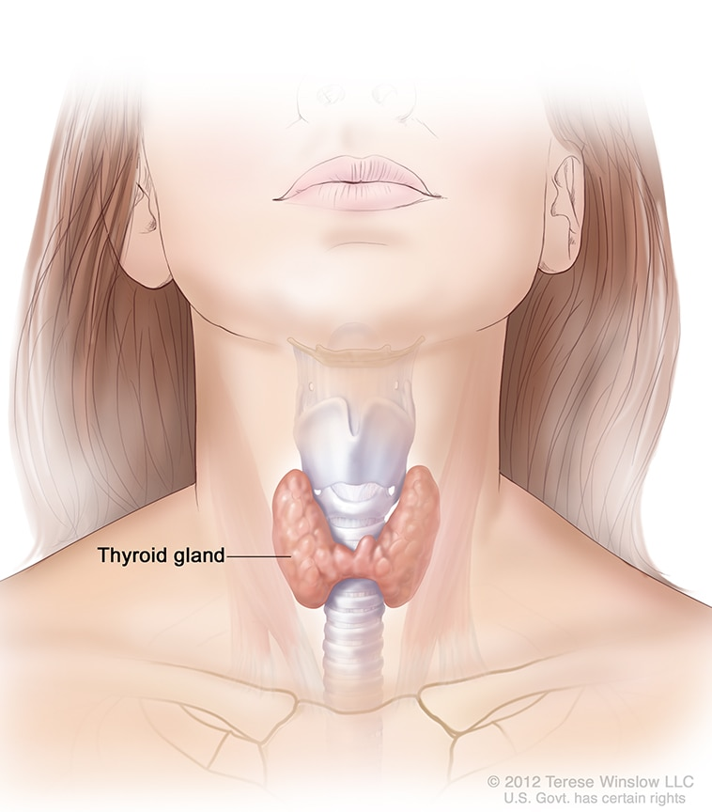

2

**CHAPTER TWO**

**THEORY**

2.1  The Anatomy of Human Thyroid Gland:

The thyroid gland is a butterfly shaped, vascular, red-brown endocrine gland situated in the midline of the anterior neck. Under normal circumstances, it extends from the level of the 5th cervical vertebra (C5) to the first thoracic vertebra (T1).

On average, the gland weighs between 15 to 25 g, and is the largest of the endocrine glands. The irregular structure is encased in the pretrachealpart of the deep cervical fascia. It is made up of a central isthmus that connects the right and left lobes of the organ inferomedially. Between the ages of 8 months to 15 years, the thyroid gland appears the same in both males and females. However, the gland is slightly heavier in females over the age of 15 than in male counterparts of similar age. Each lobe is roughly conical in shape, with each apex pointing superolaterally and their bases inferomedially (between the 4th and 5th tracheal rings). At their widest point, each lobe measures about 3 cm in the transverse plane, and 2 cm in the anteroposteriordimension. The lobes are roughly 5 cm long. The isthmus lies above the 2nd or 3rd tracheal cartilages and measures 1.25 cm in both the transverse and vertical planes. In some individuals, there may be a third lobe of the thyroid gland known as the pyramidal lobe. It is also a conical structure that extends from the isthmus up to the hyoid bone. In some cases, it may also arise from the inferomedial aspect of either left or right lobes; but it is more commonly seen arising from the left lobe [Lorenzo Crumbie],2023.

3

2.2  Physiology Of Thyroid Gland:

T3 is responsible for affecting many organs and tissues throughout the body, which can, in summary, is the effect of increasing metabolic rate and protein synthesis. Parafollicular cells, or C cells, are responsible for the production and secretion of calcitonin. Calcitonin opposes parathyroid hormone to decrease blood calcium levels and maintain calcium homeostasis [Duran, İ.D., et al, 2019].

The physiological effects of thyroid hormones are listed below [Shahid, M.A., et al, 2018]:

• Increases the basal metabolic rate

• Depending on the metabolic status, it can induce lipolysis or lipid synthesis.

• Stimulate the metabolism of carbohydrates

• Anabolism of proteins. Thyroid hormones can also induce catabolism of proteins in high doses.

• Permissive effect on catecholamines

• In children, thyroid hormones act synergistically with growth hormone to stimulate bone growth.

• The impact of thyroid hormone on CNS is important. During the prenatal period, it is needed for the maturation of the brain. In adults, it can affect mood. Hyperthyroidism can lead to hyperexcitability and irritability. Hypothyroidism can cause impaired memory, slowed speech, and sleepiness.

• Thyroid hormone affects fertility, ovulation, and menstruation.

4

2.3 Thyroid Hormone Levels:

1.  Thyroid Stimulating Hormone (TSH)

-TSH is the most sensitive marker for assessing thyroid function. It is produced by the pituitary gland and stimulates the thyroid gland to produce thyroid hormones.

- Low TSH levels indicate hyperthyroidism, while high TSH levels suggest hypothyroidism.

- The reference range for TSH levels may vary depending on the laboratory, but typically falls between 0.4 to 4.0 mU/L.

2.  Free Thyroxin (FT4):

- FT4 is the active form of thyroid hormone that circulates in the bloodstream and is available for use by the body's cells.

- Low FT4 levels are indicative of hypothyroidism, while high FT4 levels may suggest hyperthyroidism.

- The reference range for FT4 levels is usually between 0.8 to 1.8 ng/dL.

3. Free Triiodothyronine (FT3)

- FT3 is another active form of thyroid hormone that plays a role in regulating metabolism and energy production.

- FT3 levels are typically elevated in hyperthyroidism and decreased in hypothyroidism.

- The reference range for FT3 levels is around 2.3 to 4.2 pg/mL.

4. Thyroid Antibodies:

- Thyroid peroxidase antibodies (TPOAb) and thyroglobulin antibodies (TgAb) are markers of autoimmune thyroid disease, such as Hashimoto's thyroiditis and Graves' disease.

5

- Elevated levels of thyroid antibodies may indicate an autoimmune thyroid condition.

5. . Reverse T3 (rT3):

- Reverse T3 is an inactive form of thyroid hormone that may be elevated in conditions of stress or illness.

- Elevated rT3 levels can interfere with the action of active thyroid hormones and contribute to a state of thyroid hormone resistance.

6.  Interpretation:

- Interpretation of thyroid hormone levels should be done in conjunction with clinical symptoms, physical examination findings, and other relevant laboratory tests.

- Treatment decisions should be based on a comprehensive assessment of thyroid function, taking into account the patient's overall health status and individual factors.

Regular monitoring of thyroid hormone levels is essential for managing thyroid disorders effectively and optimizing patient outcomes. Close collaboration between healthcare providers and endocrinologists can help ensure appropriate evaluation and management of thyroid hormone imbalances.

6

**2.4 Types of thyroid disease**:

There are several types of thyroid disease, which include [Brent GA., 2022]:

1. Hyperthyroidism: An overactive thyroid that occurs as a result of your body producing too much thyroid hormone.

2. Hypothyroidism: An underactive thyroid that can happen when your body isn’t able to create enough thyroid hormone.

3. Thyroid nodules: Lumps that are either solid or filled with fluid that grow in your thyroid.

4. Goiter: An enlarged thyroid .

5. Thyroiditis: Swelling or inflammation of your thyroid gland.

6. Thyroid cancer: Growth of cancer cells in your thyroid

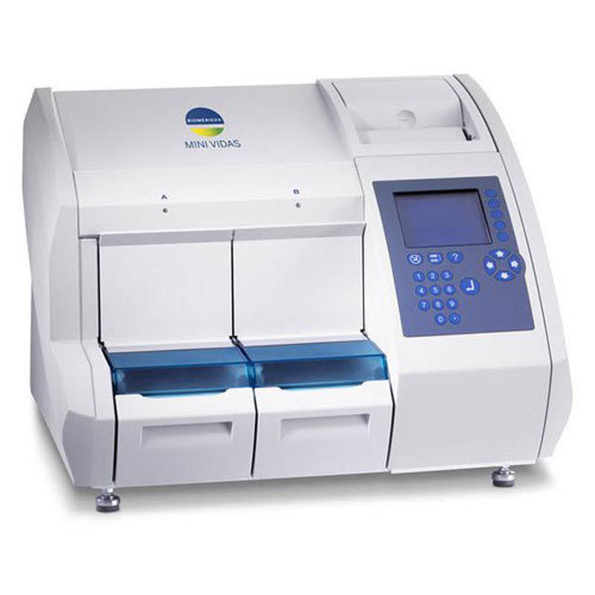

7

**CHAPTER THREE**

**METHODOLOGY**

When obtaining samples from patients with thyroid hormone disease, it is crucial to follow specific guidelines to ensure accurate results and proper management of the condition. Here are some key points to consider when taking samples from patients with thyroid hormone disease:

1. Blood Samples:

- Thyroid function tests typically involve measuring levels of thyroid-stimulating hormone (TSH), free thyroxine (T4), and sometimes triiodothyronine (T3) in the blood.

- Use aseptic technique when collecting blood samples to prevent contamination.

- Consider the timing of blood sample collection, as TSH levels exhibit diurnal variation with highest levels in the early morning.

- Ensure that the patient has been fasting if necessary for specific tests, such as TSH measurement.

2. Thyroid Ultrasound:

- In cases where structural abnormalities of the thyroid gland are suspected, a thyroid ultrasound may be indicated to assess the size, shape, and characteristics of the thyroid gland.

- Ensure that the patient is positioned appropriately for the ultrasound examination to obtain clear images of the thyroid gland.

8

3. Fine-Needle Aspiration (FNA) Biopsy:

- If a thyroid nodule is identified on ultrasound and there is concern for malignancy, a fine-needle aspiration biopsy may be performed to obtain a tissue sample for analysis.

- Ensure that the patient understands the procedure and provide appropriate pre-procedure instructions, such as discontinuing anticoagulant medications if necessary.

4. Radioactive Iodine Uptake (RAIU) Test:

- In cases of hyperthyroidism, a radioactive iodine uptake test may be performed to assess thyroid function and iodine uptake by the thyroid gland.

- Provide instructions to the patient regarding any dietary restrictions or medication adjustments that may be necessary before the test.

5. Special Considerations:

- Patients with thyroid hormone disease may have comorbidities or medications that can affect thyroid function test results. Consider these factors when interpreting test results.

- Consult with an endocrinologist or thyroid specialist for guidance on appropriate testing and interpretation of results in patients with complex thyroid hormone disease.

By following these guidelines and considering the specific needs of patients with thyroid hormone disease, healthcare providers can obtain samples effectively for diagnostic purposes and monitoring of thyroid function. Close collaboration with specialists can help ensure accurate diagnosis and optimal management of thyroid hormone disorders.

9

**CHAPTER FOUR**

**RESULTS**

A total of 58 patients (pregnant, non-pregnant) women with a range of age of (16 and 67) years old participated in the study. The mean plasma thyroid hormone TSH, T3 and T4 concentrations were 5.67, 1.935 and 109.9 mg/dl respectively.

According to the collected data from Pregnant patients as shown in Table (1), the portion of women of age > 40 years old with Hyperthyrodism is 25%, hypothyroidism women is 6.25% , while the portion of women of age < 40 years old with hyperthyrodism is 16%, hypothyroidism women is 2.5%.

Investigation of the relationship between age of women and their TSH, T3 and T4 levels in serum, the TSH distribution by age groups in the study group shows a shift to higher levels in older people.

In addition, low serum free T3 concentrations mark familial longevity and extreme longevity is associated with increased serum TSH level.

|  |  |  |  |  |  |  |
| --- | --- | --- | --- | --- | --- | --- |
| No. | Name | Gender | Age | TSH level | T3  level | T4  Level |
|  | Mahabad muhamad | Female | 19 | 2.20 | 1.60 | 119.8 |
|  | Nergz abdulkarem | Female | 21 | 2.4 | 2.3 | 112.6 |
|  | Hamin khalid | Female | 28 | 1.75 | 2.18 | 119.5 |
|  | Afrah hassan | Female | 43 | 2.41 | 2.06 | 106 |
|  | Nawroz kawa | Female | 24 | 3.90 | 2.25 | 132.6 |
|  | Choman muhamad | Female | 46 | 3.21 | 1.82 | 129.5 |
|  | Tara ramazan | Female | 34 | 4.15 | 2.19 | 95.86 |
|  | Wasela hassan | Female | 67 | 0.198 | 1.47 | 112.1 |
|  | Mahabad rasul | Female | 46 | 2.43 | 1.93 | 99.5 |
|  | Aven esmail | Female | 32 | 4.20 | 2.49 | 124.6 |
|  | Kurdistan abdulla | Female | 34 | 2.94 | 1.64 | 99.11 |
|  | Paiman arkan | Female | 36 | 1.06 | 2.09 | 109.2 |
|  | Batul shawkat | Female | 18 | 4.56 | 2.31 | 174.7 |
|  | Nasiba aziz | Female | 40 | 3.01 | 1.73 | 89.53 |
|  | Kalthum nihmat | Female | 31 | 2.01 | 1.86 | 124.4 |
|  | Mahbuba sabir | Female | 41 | 1.79 | 2.04 | 137.7 |
|  | Fauzia hussin | Female | 46 | 2.63 | 1.82 | 116.2 |
|  | Halima abdulla | Female | 50 | 4.46 | 1.98 | 100.4 |
|  | Samiha shakr | Female | 23 | 4.57 | 1.93 | 100.6 |
|  | Kalsum nabi | Female | 31 | 2.01 | 1.86 | 124.4 |
|  | Taban mahmud | Female | 33 | 4.11 | 2.14 | 125 |
|  | Salwa tofiq | Female | 33 | 2.3 | 2.18 | 120.5 |
|  | Sumaya faisal | Female | 23 | 1.64 | 2.44 | 150.3 |
|  | Saja raza | Female | 40 | 4.81 | 1.42 | 104.5 |
|  | Majida fars | Female | 37 | 1.34 | 2.55 | 119.0 |
|  | Bushri muhamad | Female | 33 | 2.7 | 1.88 | 119.7 |
|  | Sakar shafiq | Female | 19 | 0.6 | 3.17 | 164 |
|  | Narmin omar | Female | 36 | 2.12 | 2.14 | 120.8 |
|  | Xanda ali | Female | 41 | 2.23 | 2.06 | 125.7 |
|  | Chawjwan omar | Female | 42 | 0.69 | 2 | 88 |
|  | Nazli saeed | Female | 39 | 2.02 | 2.09 | 121.0 |
|  | Aysha abdulla | Female | 44 | 0.927 | 1.81 | 92.73 |
|  | Shadya jamil | Female | 35 | 2.19 | 2.61 | 130.4 |
|  | Sabat bashir | Female | 34 | 1.99 | 2.38 | 133.5 |
|  | Farik hamarashed | Female | 38 | 2.23 | 1.81 | 111.1 |
|  | Sawen madhar | Female | 54 | 7.75 | 2.55 | 107.8 |
|  | Parwen abdulrahman | Female | 50 | 52.45 | 0.607 | 26.06 |
|  | Galawezh isamil | Female | 40 | 2.71 | 1.99 | 121.7 |
|  | Sakar mawlwd | Female | 34 | 2.85 | 2.02 | 108.0 |
|  | Srwa salm | Female | 30 | 3.63 | 2.09 | 156 |
|  | Hasiba najmadin | Female | 40 | 3.52 | 1.89 | 173.2 |
|  | Sora kurdi | Female | 60 | 1.51 | 1.73 | 123 |
|  | Hana othman | Female | 24 | 2.23 | 2.01 | 110.1 |
|  | Faiza sdiq | Female | 45 | 3.27 | 2.19 | 104.1 |
|  | Shadya sherzad | Female | 29 | 0.775 | 2.34 | 118.3 |
|  | Fatima faruq | Female | 16 | 0.7 | 2.9 | 149 |
|  | Kawthar qadr | Female | 50 | 1.56 | 2.26 | 150.2 |
|  | Hilen aziz | Female | 27 | 3.50 | 3.02 | 192.2 |
|  | Zina qasm | Female | 20 | 2.86 | 2.63 | 120.6 |
|  | Hero kaka | Female | 26 | 3.23 | 2.44 | 132.1 |
|  | Bnar ali | Female | 25 | 0.657 | 2.29 | 0.657 |
|  | Kanar karwan | Female | 17 | 1.62 | 2.95 | 182.2 |
|  | Badrya jabar | Female | 17 | 6.2 | 1.9 | 118.5 |
|  | Roya hawar | Female | 19 | 2.03 | 2 | 92.3 |
|  | Dlvin abdulla | Female | 27 | 1.95 | 3.5 | 183.5 |
|  | Awen nihad | Female | 26 | 8.000 | 1.88 | 78.99 |
|  | Shadi othman | Female | 21 | 2.96 | 1.89 | 111.9 |
|  | Nawroz kawa | Female | 23 | 9.15 | 2.27 | 100.0 |

11

12

**CHAPTER FOUR**

**DISCUSSION AND CONCLUSION**

4.1 Discussion:

Age-related changes can affect thyroid hormone levels in the blood. Thyroid-stimulating hormone (TSH) levels may increase with age, reflecting changes in thyroid function. When evaluating thyroid hormone levels in patients, it is crucial to consider various factors that can influence the interpretation of thyroid function tests. Here are some key points to keep in mind regarding thyroid hormone levels:

Although, subclinical hypothyroidism is associated with increased risk of cardiovascular events (Ochs et al., 2008; Razvi et al., 2008; Rodondi et al., 2010), in a study of community-dwelling older adults, higher TSH and lower free T4 concentrations within the euthyroid range were associated with lower risk of mortality (Atzmon et al., 2009). Observational studies suggest that individuals with TSH concentrations of <7 mIU/L (Rodondi et al., 2010; van Vliet et al., 2021) do not have increased risk of cardiovascular disease, dementia or increased mortality.

4.2 Conclusion:

Thyroid disease in older adults can have an atypical presentation and in some people it can be asymptomatic.

Given the high prevalence of thyroid disease and unreliability of clinical acumen in identifying thyroid dysfunction, older people presenting to health care offices should be screened for thyroid disease with TSH testing.

However, there is no consensus about screening among the experts.

13

Currently the American Thyroid Association and the American Association of Clinical Endocrinologists recommend that testing be considered for those older than age 60 (Garber et al., 2012) while the U.S. Preventive Services Task Force states that there is not enough evidence to support screening.

14

**Reference:**

* Healthdirect. (2023, March 10). Thyroid function tests. healthdirect. https://www.healthdirect.gov.au/amp/article/thyroid-function-tests
* professional, C. C. medical. (n.d.). Thyroid hormone: What it is & function. Cleveland Clinic. https://my.clevelandclinic.org/health/articles/22391-thyroid-hormone
* T3: Ionic hair dryers, ceramic curling irons, Professional Flat Irons. T3 Micro. (n.d.). https://t3micro.com/
* Thyroid function tests. American Thyroid Association. (n.d.). https://www.thyroid.org/thyroid-function-tests/
* Pirahanchi, Y. (2023, May 1). Physiology, thyroid stimulating hormone. StatPearls [Internet]. https://www.ncbi.nlm.nih.gov/books/NBK499850/
* U.S. National Library of Medicine. (2021, June 21). In brief: Understanding thyroid tests. InformedHealth.org [Internet]. https://www.ncbi.nlm.nih.gov/books/NBK279414/
* Shokripour, M., Imanieh, M. H., Garayemi, S., Omidifar, N., Shirazi Yeganeh, B., & Althabhawee, F. (2022). Thyroid stimulating hormone, T3 and T4 population-based reference range and children prevalence of thyroid dysfunction: First report from south of Iran. Iranian journal of pathology. https://www.ncbi.nlm.nih.gov/pmc/articles/PMC9745748/
* Mohanty, S. (2023, December 15). TSH test: What is T3, T4, Tsh Normal Range?. MyHealth. https://redcliffelabs.com/myhealth/lab-test/tsh-test-what-is-t3-t4-tsh-normal-range/

15