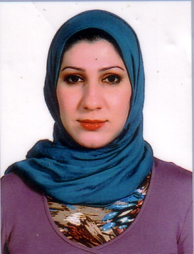
Name: Media Fadhil Jalil
Last Certificate: Master‌
Specific specialty: Biomedical engineering
Academic Title: Assistant Lecture
Instrument – laboratory technique Maintenance– Installation and calibration of medical equipment.
Years of academic experience: 5 years
E.mail: (Only EPU email): media.jalil@epu.edu.krd
CV:
Gender: female
Date of birth: 3/11/1984
Place of birth: Baghdad
Marital Status: Married
Mobil No.: +9647507315717

Language:
Language (s) Reading Writing Speaking
Excellent Excellent Excellent Kurdish
English Excellent Excellent Very good Arabic Excellent Excellent Excellent

Education:
High school
I graduated From Dijla higher school for boys in (2001-2002)

University Career
I had Graduated from Al-Nahrain University, College of Engineering .Department of biomedical engineering . (2005-2006).
I hold master degree from Al-Nahrain University, College of Engineering .Department of biomedical engineering . (2014).

Background
I worked at the Erbil Technical Institute as lecturer assistant (28/10/2014).
I worked at the Erbil Medical Technical Institute as lecturer (2014-Now)

I participated in many courses
Advanced courses in English.
Advanced courses in computer.
Course in Cisco Network.
Courses in teaching methods.

Office Phone number: +9647507315717
Research:
Removal of Tissue Via Plasma induced Ablation.

