CURRICULUM VITAE

Personal Information
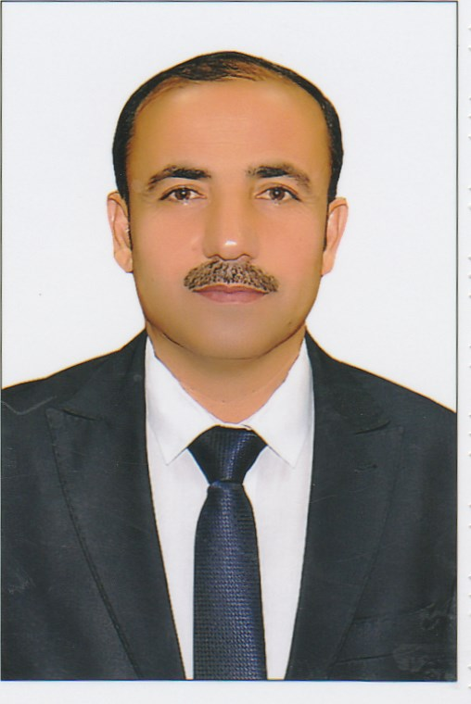
Name:kawa yasen salim
Birth Date:1Julay 1971 (Age: 48)
Gender:male
Nationality: Iraq
Marital Status:Marred
Driving License Issued:Iraq
Contact Information
Email Address: kawa71@yahoo.com
Email university: kawa.salim@epu.edu.iq
Mobile Phone: +964 750 4826797
Country: Kurdistan Region- Iraq
Address: Iraq-Erbil-Zanko Q.
Qualifications:
Bachelor’s degree–Law Departmentat Salahaddin University-College of Law
Location: Erbil, Iraq
Completion Date: 1997-1998
Result: successful
Date of First Assignment in University :25 th March 1999

M.sc in Law (public Law) University of Alexandria
Location: Egypt - Alexandria
Completion Date: 2014
Result: successful– Excellent
Title of the research The publication of thebook "The Role of the Administrative Judiciary in the Protection of Public Rights and Freedoms" - Comparative Study of Egypt and Iraq. New University House, Alexandria - Egypt - 2014.

PhD in Law-(public Law) University of Alexandria - Faculty of Law
Location: Egypt- Alexandria
Completion Date: June - 2016
Result: successful – Excellent
The title of the research is published as abook (legal organization for human rights guarantees). Modern University Office, Alexandria - Egypt, 2017.

Experience (17Years)
Teacher at University of ERBIL POLYTECHNIC UNIVERSITY
Location: -Erbil, Iraq
Company Industry: Education
Job Role: Teacher
2015 - 2016
Teacher at Erbil Technical Institute
Location: -Erbil - Iraq
Company Industry: Education
Job Role: Teacher -2017
Now:I work as Head of Legal Administration Department
Presented( part time) at Tishk University - Faculty of Law (2016 - 2017) and (2017 - 2018)(2018-2019).

Conference Attended
- International scientific conferences:
Strategies of Reconstructing the National Finance and Society Development the Next Time from 7-8 November 2012
2 - Research published on the fight against terrorism and the right to privacy - The Second International Conference of Legal Issues - 11/5/2017 Faculty of Law University of Ishak - Erbil

3. The conference is jointly organized by the University of Salahaddin and the Center for the Sykes-Picot Convention - DizkaiRushnberry and Rakihiandani (B-D-K) - 16/5/2016.
4. Communication engineering and computer science (cic-cocos 17) - Cihan university erbil - 29-30 / march / 2016
5 - The Third International Scientific Conference of the University of Ceyhan - Erbil Law and International Relations and Information - ZanquiJehan - 12-13 April 2017.
6- Biological sciences (CIC-BIOS 19 - Cihan university erbil - 26-27 April 2017.
7 - Presenting dozens of seminars and participation of different legal subjects in the universities of the Kurdistan region.
8. Acceptance of the publication of the research entitled (Administrative control over the legality of the work of the administration). The Third International Conference of Legal Issues, 2018, Faculty of Law, Iskk University, Erbil, in collaboration with Salahuddin University.
9 - Registration of two researches at the Technical Institute Khubat entitled:
1- Legal regulation of the public employee's right to strike.
2. Administrative control over the legitimacy of the work of the administration.
- بحث منشور بعنوان (مكافحة الارهاب وحق الانسان في الخصوصية-( المؤتمر الدولي الثاني للقضايا القانونية- - 11/5/2017- كلية القانون جامعة ايشك- اربيل
- بحث منشور بعنوان(الرقابة على مشروعية اعمال الادارة) مجلة كلية القانون والعلوم السياسية – جامعة صلاح الدين – 2018
- بحث منشور بعنوان (التنظيم القانوني لحق الموظف العام في الاضراب) كلية القانون والعلوم السياسية جامعة كركوك.
- بحث مشارك في ملتقى الدولي الثاني لجامعة صلاح الدين و منظنة حكماء العراق بعنوان (دور الجامعات في نشر وتوعية وارشاد فكر التعايش السلمي رؤى مستقبلية)
- بحث مشارك في المؤتمر القانوني لجامعة تيشك 2019 بعنوان (نظريتي القوة القاهرة والظروف الطارئة في القانون والشريعة الاسلامية).

Skills
Higher Education
Level: Expert
Experience:17years or more
Last Used: Until now

ITWord Excel Power Point Windows
LevelV.GoodGood ExcellentExcellent

Languages:
Language Reading Listening Writing Speaking
English V.GoodV.GoodV.GoodV.Good
Arabic Excellent Excellen Excellent Excellen
Kurdish Excellent ExcellentExcellent
- TOEFL Certificate 2013.
- Certificate of three-month Ilets course (Technical Diploma in Technical Education, 2016)

Hobbies:
1. Education 2. Languages
3. Redding 4. Working
5. Sport 6. Science

Target Job:
Target Job Title: Law
Target Job Location: Erbil, Iraq
Career Objective: To develop and growth my experience and country
Target Industry:Education and pablic Law
Employment Type:Employee
Employment Status:Full time

Assignments and posts

- Chief of Information in the College of law Salahaddin University
- Library Manager in the College of Law – Salahaddin University
- Department Official Computer Department in the College of Law - Salahaddin University
- Internet Department Supervisor in the College of Law - Salahaddin University
- Accountant in the Chwarchra Hotel for ( Four ) years
- Selling Analyst in the Erbil Tower Hotel
- Member of Kurdistan Jurists Union
- Manager of Cartography and Painting office
- in Charge of Scintific Research Department in the college of Law - Salahaddin University
- Member of the Supervision Committee on the Ballot – Boxes in Kurdistan Region
- Personnel Manager of Centrefor Scientific Research

