CV/ Israa Akram Saleem
Name: Israa Akram Saleem
Family name : Saleem
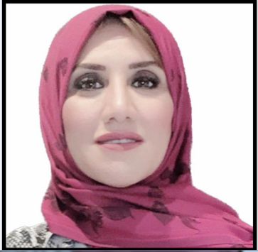
Marital status: Married, two children
Nationality: Iraqi
Gender: Female
Birth place: Mosul
Address: Zanko2/Erbil
Mobile:07508404618
E-mail:ms_israa2000@yahoo.com
Israasaleem@epu.edu.iq
Qualifications:-
Education:
B.Sc University of Mosul /College of Education /Physic Department(1997)
M.Sc. University of Salahaddin / College of Education /Physic Department(2002)

Ph.D Alexandria University/ Medical Research Institute/ Medical Biophysics
Department(2022)

9/2019-10/2022
Study of advance course in Medical Biophysics to get Ph.D Degree from Alexandria university / Medical Research Institute/ Medical Biophysics
Department

9/2018-2019
Technology college of Management-Erbil/Responsible Units of Statistic and Educational quality of College /teaching the following subjects:
1-Scientific-Research-3st year.
2- Academic Debate^{1st} year

9/2015-2018
Technology college of Management-Erbil/Responsible of Statistic Unit of the College /teaching Scientific-Research-3st year.

9/2011-2015:-
Technology college of Management-Erbil/Department of Financial Science and Accounting, teaching of the following subjects:

- Computer program MS-Excel) -2 st year
- Mathematics -1st year
- Statistical Principles -1st year

9/2006-2012:-
Technology college-Erbil/Department of Financial Science and Accounting / Assistant of head Accounting and Finance Dep and Member examination committee, teaching of the following subjects:

1-Computer program MS-Excel) -2 st year
2-Mathematics -1st year .

9/2004-2006:-
Technology college-Erbil/Department of Financial Science and Accounting / Assistant of head Accounting and Finance Dep and Member examination committee, teaching of the following subjects:
1-Basic language-1 st year
2-Computer program(MS-Dos, MS-Word, MS-Excel) -2 st year
3-Mathematics -1st year in Financial Science and Accounting & Construction Engineering Technology Department.
4-Laser -2 st year in Electric Department

9/2002-9/2004:-
Technical Institute of Erbil / Computer center Unit /teacher, teaching the following :
- Computer program(MS-Dos ,Windows)- 1st year in Electric Department
- Computer program(MS-Excel )- 2 st in Libraries Department
- Work shop – 1 st year in Electric Department

12/1999- 7/2002:-

Study of advance course in Physical to get M.Sc Degree from university of Salahaddin/Physic Department.

6/1997- 6/1994:-

Study in College of Education /Physic Department to get B.Sc Degree from University of Mosul.

Training Courses:
1-Teaching Methods
2- English Proficiency Course

