 | Erbil Polytechnic University  Erbil Technology College  Department of Automation Industrial Technology  Certificate of Participation |  |  |  |  | 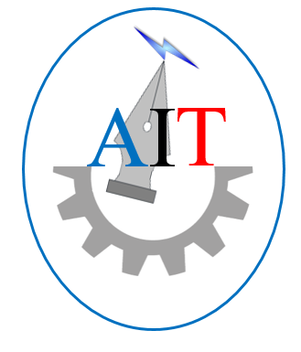
 |  | This acknowledges that
 | Ramazan Safar Wahid
 |  | Has successfully completed the training program on Classical and Modern PLC Technology Controllers which held in Erbil Technology College from 5th of July to 17th of July 2022

Assistant Lecturer Assistant Lecturer Lecturer Assistant Prof.
Abubaker Aziz Ahmed Hussein Ali Ibrahim Brzo Aziz Qadir Dr. Botan Majeed Asinger
Instructor Instructor Head of Department Dean of College

