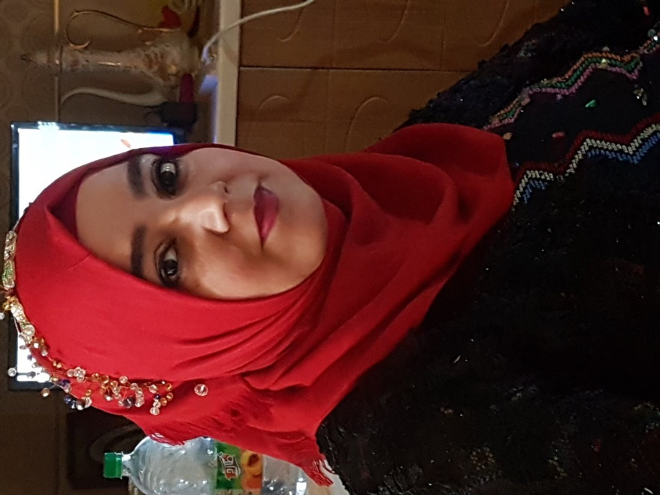 |  | Hataw Jalal Taher  Assistant Lecturer in Microbiology  Birth date: 15 July 1982  Nationality: Iraq- Kurdistan Region - Erbil  Address: 27A New Zanko Village- Erbil  E-mail: hataw.taher@epu.edu.iq
Publications  - Impacts of Cinnamon and Thyme essential oils against the growth of Staphylococcus aureus  HJ Taher, MHA Rasool  Polytechnic Journal 7 (2)  - Screening of IgM and IgG Against Cytomegalovirus, Rubella and Toxoplasma infections in Aborted Women in Erbil Province-Iraqi Kurdistan Region  YK Amin, HJ Taher, MHA Rasul  Contact  EMAIL:  hataw.taher@epu.edu.iq |  | EDUCATION  - M.Sc. degree in Microbiology (2005-2008) –Biology Dept., College of Science, Salahaddin University- Erbil.  - B.Sc. degree in Biology (2001-2005) –Biology Dept., College of Science, Salahaddin University- Erbil.  WORK EXPERIENCE  Working as biology assist. in biology dept. , college of science, Salahaddin university  Serving as Assistant Lecturer in Medical tech. Inst. , Polytechnic university  Serving as Assistant Lecturer in MLT dept.,Erbil Health tech. college , Polytechnic university  SKILLS  Languages (Speaking, writing and reading):  - Kurdish  - Arabic  - English

