**وزارة العالي والبحث العلمي –اقليم كردستان**

**جامعة اربيل التقنية كلية شقلاوة التقنية**

**قسم البيطرة**

**المرحلة الثانية/ الصباحي**

**Ministry of High Education and scientific research**

**Erbil polytechnic University**

**Shaqlawa technical college**

**Veterinary department**

**Stage Two/Morning**



**Effect of vit AD3E for dairy cattle on period of milk production**

A research project submitted to the board of the veterinary department as a part of the requirements for obtaining diploma in veterinary sciences

Prepared by students

Mohammed .S.Ebrahim Miran.J.Kader

Ahmed.A.Bahram Hilal Mohammed

Supervisor

MSc.Fawzyea Beia Toma

2023-2024

**Declaration of supervisor**

I certify that this research is under the title (Infertility of Dairy Cattle).Presented by the students:

Mohammed .S.Ebrahim Miran.J.Kader Ahmed.A.Bahram Hilal Mohammed

It took place under my supervision at the Shaqlawa Technical College as part of the requirements for obtaining a diploma in veterinary medicine.

Signature:

The name: MSc.Fawzyea Beia Toma

Date:

Based on the available recommendations, I nominate the research for discussion.

Signature:

The name: Assis proff .Dr. Hassan.A.Mohammed / Head of department

Date:

**A**

**The approval of the discussion committee**

We, the members of the discussion committee, the undersigned, certify that we have seen this research decree { **Effect of vit AD3E for dairy cattle on period of milk production**}.

Presented by the students:

Mohammed .S.Ebrahim Miran.J.Kader Ahmed.A.Bahram Hilal Mohammed

We have discussed with the students its contents and what is related to it as part of the requirements for obtaining a diploma in (veterinary), and we found it fulfilling the requirements of the certificate.

Head of committee: Dr. Kammran Muhammed Husien / / 2024

Dr. Dr. Dr.

Member Member Member

2023 2023 2023

B

**Abstract**

Dairy cattle nutrition plays a crucial role in optimizing milk production, and adequate vitamin supplementation is essential for the overall health and productivity of dairy herds. This study investigates the effects of Vitamin AD3E supplementation on the period of milk production in dairy cattle. The experimental design involves a randomized control trial with a focus on assessing milk yield, milk composition, and the overall health of the animals.

A group of lactating dairy cows is divided into two cohorts: one receiving a standard diet, and the other receiving the same diet supplemented with Vitamin AD3E. The study monitors and compares milk production parameters, including daily milk yield, milk fat content, protein content, and lactose levels over a defined period.

Preliminary findings suggest that dairy cattle receiving Vitamin AD3E supplementation exhibit notable improvements in milk production compared to the control group. The supplemented group demonstrates increased daily milk yield, enhanced milk quality with higher fat and protein content, and improved lactose levels. Additionally, the study assesses the impact of Vitamin AD3E on the health indicators of the cattle, including reproductive performance and overall well-being.

This research contributes valuable insights into the potential benefits of Vitamin AD3E supplementation in enhancing milk production in dairy cattle. The outcomes of this study may have implications for optimizing nutritional strategies in dairy farming, offering a sustainable approach to improving herd productivity and maintaining the health and vitality of dairy cattle. Further research and long-term monitoring will be crucial to validate these findings and establish practical recommendations for the incorporation of Vitamin AD3E in dairy cattle nutrition programs.

C

**Dedication**

When we cross the sea of hard work,

Only those who planted a beautiful flower on our way to overcome difficulties remain within us.

My letters can only be words of thanks and dedication to my beloved family and my honorable teachers

**Researchers**

**D**

**Aknowlgment**

Praise be to God, the Generous, the Compassionate, the Most Merciful, who created man, taught him the eloquence, and spoke his tongue with remembrance and the Qur’an.

I raise and refrain from submission to God, the Exalted, the Most Exalted, Who corrected my mistakes and enabled me to complete this study after what was good for me at the hands of all those who pledged me to take care of the virtuous scholars, pious fathers, loyal companions, and generous people who gave me all their effort and knowledge without tirelessness and boredom. And in accordance with the saying of the Almighty (I do not waste the reward of the best work). I present to all of them in my name the verses of thanks and gratitude, asking God Almighty to reward them, and may my Lord reward them on my behalf with the best reward, and to make their deeds with me a weight in the balance of their good deeds and an intercessor for them on the day of presentation to you.

Hence, I am true to the saying [Be humble to whomever you know from]. We extend our thanks, appreciation, credit and gratitude to my professor, Dr.: Hassan Abdullah Muhammad, the supervisor of the research, who provided us with a single example of scientific enrichment and a careful follow-up of all our steps in preparing the research. We can only pray to God to reward him for all. It is good to give him health to communicate his human and scientific giving without limits.

We would also like to extend our sincere thanks and great gratitude to everyone who contributed to helping us, directing and guiding us, based on the saying of our Messenger, may God’s prayers and peace be upon him, “He who does not thank people does not thank God.

**E**

**List of content**

|  |  |  |
| --- | --- | --- |
| No . | subject | page |
|  | Declaration of supervisor | A |
| The approval of the discussion committee | B |
| Summary | C |
| Dedication | D |
| Aknowlgment | E |
| List of content | F |
| List of tables | G |
| List of figures | G |
| 1 | Introduction | 1 |
| 2 | Causes of infertility | 2 |
| 2-1 | Infertility due to malnutrition | 3 |
| 2.1.1 | Prevention of nutritional infertility | 6 |
| 2.2 | Congenital infertility | 8 |
| 2.3 | Age-related infertility in cows | 8 |
| 2.4 | Infertility resulting from mistakes in breeding | 9 |
| 2.5 | Infertility resulting from diseases of the reproductive system: | 10 |
| 2.5.1 | Placental retention | 10 |
| 2.5.2 | Causes of placenta retention | 11 |
| 2.5.3 | Placental retention treatment | 11 |
| 2.6 | Uterine relapse | 12 |
| 2.7 | Inflammation of the uterus | 14 |
| 2.7.1 | Treatment of uterine infection | 15 |
| 2.8 | polycystic ovarian follicles | 16 |
| 2.8.1 | Cyst lutetium | 18 |
| 2.8.2 | Luteal cyst | 19 |
| 2.9 | Permanent corpus luteum | 20 |
| 2.10 | Lethargy of the ovaries | 23 |
| 2.11 | Infertility caused by immune factors | 24 |
| 2.12 | Infertility resulting from poorly organized artificial insemination | 25 |
| 3. | Conclusion and Recommendation | 26 |
| 3.1 | Conclusion | 26 |
| 3.2 | Recommendation | 27 |
|  | پوخته‌ | 29 |
| 4 | References | 31 |

**F**

**List of tables**

|  |  |  |
| --- | --- | --- |
| page | Name of table | No. |
| 6 | Vitamin needs of cows according to their production status | 1 |
| 7 | Cows' need for mineral elements | 2 |

**List of figures**

|  |  |  |
| --- | --- | --- |
| page | Name of table | No. |
| 16 | Secrete estrogen | 1 |
| 19 | State of estrus | 2 |
| 20 | Surface of the ovary | 3 |
| 21 | Graf's follicle growth | 4 |

**G**

1. **Introduction**

Dairy farming plays a crucial role in meeting the global demand for high-quality milk and dairy products. To ensure optimal productivity and overall health in dairy cattle, proper nutrition is paramount. Among the essential nutrients, vitamins A, D3, and E stand out for their pivotal roles in various physiological processes. This introduction aims to explore the multifaceted effects of vitamin AD3E supplementation on the period of milk production in dairy cattle, shedding light on the intricate interplay between these vitamins and the intricate biology of lactating cows. Vitamins A, D3, and E are integral components of a dairy cow's diet, influencing growth, reproduction, immune function, and milk production. Vitamin A is crucial for maintaining vision, immune function, and epithelial integrity. Vitamin D3 regulates calcium and phosphorus metabolism, ensuring proper bone development and preventing disorders such as hypocalcemia. Meanwhile, Vitamin E, as a potent antioxidant, protects cell membranes and enhances immune responses.

The lactation period in dairy cattle is a demanding physiological state, requiring a careful balance of nutrients to support the synthesis and secretion of milk. Vitamin AD3E supplementation is recognized for its potential to positively impact milk yield and quality. Several studies have suggested that adequate levels of these vitamins can enhance milk production, prolong lactation, and improve the overall well-being of dairy cows.

Moreover, the intricate relationships between these vitamins are noteworthy. Vitamin D3, for example, facilitates calcium absorption, a mineral crucial for milk synthesis. Vitamin A and E, with their antioxidant properties, contribute to the overall health of mammary tissues, indirectly influencing milk production. Understanding these interconnected mechanisms is essential for formulating effective dietary strategies that address the specific needs of lactating dairy cattle.

As we delve into the nuances of vitamin AD3E supplementation, it becomes evident that a comprehensive approach to nutrition is vital for unlocking the full potential of dairy cows during the critical period of milk production. This exploration aims to provide insights into the synergistic effects of these vitamins, emphasizing their impact on lactation performance and the overall welfare of dairy herds. By unraveling the intricacies of vitamin A, D3, and E interactions, we can pave the way for advancements in dairy nutrition, ensuring sustainable and efficient milk production in the dairy industry.

1. 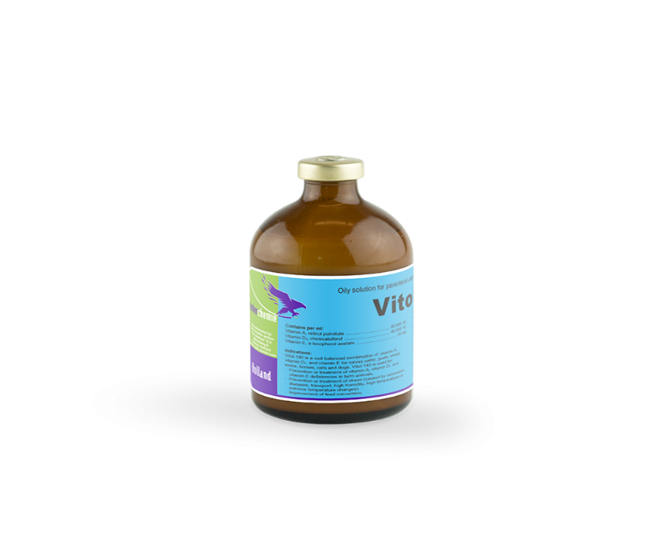**Literature review**
   1. Vitamin AD3E injection

Solution for parenteral administration

Composition

Contains per ml:

Vitamin A, retinol palmitate80000 IU.

Vitamin D3, cholecalciferol40000 IU.

Vitamin E, α-tocopherol acetate20 mg.

Excipients ad1 ml.

**2.1.1. Description**

Vitamin A is involved in the process of formation and preservation of function of epithelial tissues and mucous membranes, is important for fertility and is essential for vision. Vitamin D3 regulates and corrects calcium and phosphate metabolism in blood and plays an important role in the uptake of calcium and phosphate from the intestines. Especially in young, growing animals vitamin D3 is essential for the normal development of skeleton and teeth. Vitamin E is, as a fat-soluble intracellular antioxidant, involved in stabilising unsaturated fatty acids, thereby preventing toxic lipo-peroxides formation. Furthermore, vitamin E protects the oxygen-sensitive vitamin A from oxidative destruction in this preparation.

**2.1.2. Indications**

Vitol-140 is a well-balanced combination of vitamin A, vitamin D3 and vitamin E for calves, cattle, goats, sheep, swine, horses, cats and dogs. Vitol-140 is used for:  
- Prevention or treatment of vitamin A, vitamin D3 and vitamin E deficiencies in farm animals.  
- Prevention or treatment of stress (caused by vaccination, diseases, transport, high humidity, high temperatures or extreme temperature changes).  
- Improvement of feed conversion.

.

Side effects

No undesirable effects are to be expected when the prescribed dosage regimen is followed.

Dosage

For intramuscular or subcutaneous administration:  
Cattle and horses : 10 ml.  
Calves and foals : 5 ml.  
Goats and sheep : 3 ml.  
Swine : 5 - 8 ml.  
Dogs : 1 - 5 ml.  
Piglets : 1 - 3 ml.  
Cats : 1 - 2 ml.

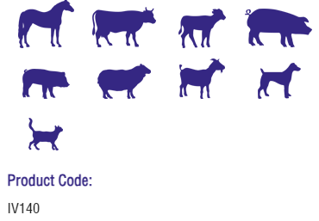

Top of Form

**2.1.3. Content of Vit AD3E**

**Vitamin A (Retinol):**

**Vision and Reproduction:** Vitamin A is essential for maintaining good vision and reproductive health in dairy cattle. Proper vision is crucial for locating and consuming feed, and reproductive health is directly linked to the overall productivity of the herd.

**Immune Function:** Vitamin A is also important for the proper functioning of the immune system, helping dairy cattle resist and recover from diseases.

**Vitamin D3 (Cholecalciferol):**

**Calcium and Phosphorus Metabolism:** Vitamin D3 plays a key role in the regulation of calcium and phosphorus metabolism. Adequate levels of these minerals are essential for the formation and maintenance of strong bones and teeth in dairy cattle.

**Reproductive Health:** Vitamin D3 is involved in the regulation of reproductive hormones, contributing to the overall reproductive health of the herd.

**Vitamin E (Tocopherol):**

**Antioxidant Properties:** Vitamin E is a powerful antioxidant that helps protect cells from damage caused by free radicals. This is particularly important in high-producing dairy cattle, as oxidative stress can occur due to the demands of milk production.

**Immune Function:** Similar to vitamin A, vitamin E supports the immune system, helping dairy cattle resist diseases and infections.

**Overall Impact on Milk Production:**

**Health and Immunity:** The combination of these vitamins supports the overall health and immunity of dairy cattle. Healthy cows are more likely to produce milk efficiently.

**Reproductive Performance:** Proper reproductive health contributes to maintaining a consistent breeding and calving schedule, ensuring a steady milk supply.

**Bone Health:** Adequate levels of vitamin D contribute to strong bones, which is crucial for supporting the body weight of the dairy cow and ensuring longevity in milk production.

**Role of vit AD3E of injection in farm animals**

All farm animals need vitamins A, D3, E for the purpose of increasing and improving the performance and maintenance of health, these requirements are determined by many factors such as the age of the animal, gender, the physiological state, the extent of its availability in the animal feed, as well as the efficiency and preparation of microorganisms in the rumen (Hafez 2012). Vitamin A has an active role in maintaining all epithelial cells in the body and plays an important role in the vision process, sperm and bone growth (Tanumihardjo 2011). Vitamin A is essential for the maintenance of organ function in general and reproductive function in particular. It plays an important role in sexual maturity, maturity, testicular size, and characteristics of semen (Fennema 2008). Vitamin D3 has an important role in improving the absorption of calcium, phosphorus in addition to the formation and calcification of the bones of the animal. It also helps prevent the reduction of calcium from the natural levels, thus reshaping the bone plate and the formation of bone. It has an active role in increasing the absorption of iron, zinc, magnesium, and phosphorus from the systemic channel (Institute of Medicine 2013). Vitamin E is a fat-soluble vitamin that is essential for growth, the perpetuation of reproduction and affects several biological processes and processes, including sperm formation, semen quality, reproduction, libido, as well as it considered as antioxidants (Liu 2006). Several studies have confirmed that vitamin E is positively affecting the immune response, helps to resist oxidation and the production of peroxides, as well as reducing the oxidation process of cell wall phospholipid, the quality of the semen in the mammals is generally affected by the lack of vitamin E in the diet, this effect includes sperm motility, concentration, ejaculate volume, and increased dead and abnormal sperm levels (Koyuncu and Yerlikaya 2007; Ali et al 2009; Yue et al 2010).

chromeextension://efaidnbmnnnibpcajpcglclefindmkaj/https://faculty.uobasrah.edu.iq/uploads/publications/1647551297.pdf

* 1. **Results of some study role of Vit AD3E on production of milk in dairy cattle** 
     1. **Results of study (Nelson ET AL., 2016)**

**Vitamin D Status of Dairy Heifers**

The serum 25(OH)D concentrations of 12-mo-old Holstein [heifers](https://www.sciencedirect.com/topics/agricultural-and-biological-sciences/heifer) from herds 3 and 9 are listed in [Table 1](https://www.sciencedirect.com/science/article/pii/S002203021630707X#tbl0005).

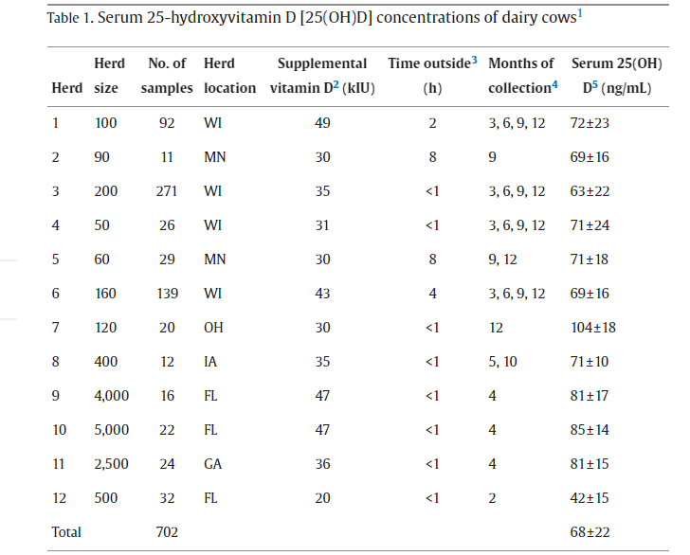

The heifers from those herds were housed outdoors on dry lots. Serum samples were collected during the month of April (n = 20/herd) and the estimated amounts of daily supplemental vitamin D3 were near 11,000 IU and 12,000 IU for each herd. The corresponding serum 25(OH)D concentrations on average were 69 ± 8 and 82 ± 18 ng/mL, respectively. The NRC recommendation for dairy heifers is roughly 1,200 IU of vitamin D3/kg of DM, or near 9,000 IU/d for a [yearling](https://www.sciencedirect.com/topics/agricultural-and-biological-sciences/yearlings) heifer. From our data, the NRC rate for dairy heifers seems to achieve serum 25(OH)D concentrations similar to what a lactating cow achieves with 1,200 to 2,000 IU of supplemental vitamin D3/kg of DM.

The importance of supplemental vitamin D3 for dairy heifers is underscored by a recent study of serum 25(OH)D concentrations of [feedlot](https://www.sciencedirect.com/topics/agricultural-and-biological-sciences/feedlot) calves ([Casas et al., 2015](https://www.sciencedirect.com/science/article/pii/S002203021630707X#bib0015)). Serum 25(OH)D concentrations were between 50 and 60 ng/mL, on average, in nearly 200 beef calves coming off summer pasture as they entered the feedlot. In the following month (March), their serum 25(OH)D had dropped to below 20 ng/mL, on average. The calves were in an open feedlot in Nebraska and received between 800 to 1,200 IU of vitamin D3/d. In another study, serum 25(OH)D of feedlot steers housed indoors without supplemental vitamin D3 dropped below 10 ng/mL, whereas those fed 1,860 IU of vitamin D3/kg of DM achieved serum 25(OH)D concentration near 70 ng/mL ([Pickworth et al., 2012](https://www.sciencedirect.com/science/article/pii/S002203021630707X" \l "bib0150)). It is often assumed that endogenous vitamin D3 synthesis of cattle housed outdoors along with vitamin D2 from forages is adequate for cattle, but that assumption could be detrimental to dairy heifers. Besides a role for vitamin D in immunity and growth, recent work using rodent models has shown that vitamin D deficiency in the prepubertal period negatively affects [reproductive performance](https://www.sciencedirect.com/topics/agricultural-and-biological-sciences/reproductive-performance) ([Dicken et al., 2012](https://www.sciencedirect.com/science/article/pii/S002203021630707X" \l "bib0025)). As with lactating cows, a lack of data exists on the dose response of serum 25(OH)D of dairy heifers to supplemental vitamin D3, but, according to available data, feeding between 1,200 to 1,500 IU vitamin D3/kg of DM achieves adequate serum 25(OH)D in dairy heifers.

**Vitamin D Status of Dairy Calves**

Adequate vitamin D nutrition for young dairy calves is critical because of their rapid growth and metabolism of 25(OH)D ([Rajaraman et al., 1997](https://www.sciencedirect.com/science/article/pii/S002203021630707X" \l "bib0155); [Nonnecke et al., 2009](https://www.sciencedirect.com/science/article/pii/S002203021630707X" \l "bib0135)). Serum 25(OH)D concentrations of preweaned dairy calves across different husbandry and nutritional practices according to age are shown in [Figure](https://www.sciencedirect.com/science/article/pii/S002203021630707X#fig0020) 1. The average 25(OH)D concentration of all calves less than 3 d of age was 15 ± 11 ng/mL, with a range of 0 to 39 ng/mL. Newborn calves typically have considerably lower serum 25(OH)D than mature animals ([Horst and Littledike, 1982](https://www.sciencedirect.com/science/article/pii/S002203021630707X#bib0060)); their serum 25(OH)D also correlates with that of their dams. Thus, the vitamin D status of the newborn calf is a reflection of dry cow nutrition ([Goff et al., 1982](https://www.sciencedirect.com/science/article/pii/S002203021630707X#bib0040); [Weiss et al., 2015](https://www.sciencedirect.com/science/article/pii/S002203021630707X#bib0205)). Despite the expectation that newborn serum 25(OH)D will be lower than that of adult animals at birth, the prevalence of calves with serum 25(OH)D below 20 ng/mL at birth is a concern. More than 25% of the newborn calves had serum 25(OH)D concentrations below 10 ng/mL; which, left untreated, puts them at great risk for impaired health and development.

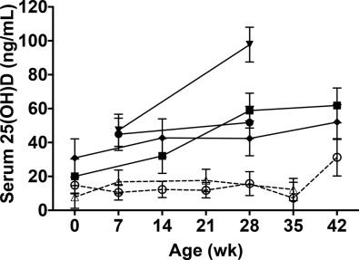

**Figure 1 Serum 25-hydroxyvitamin D [25(OH)D] of Holstein dairy calves according to various housing and**[**nutrition**](https://www.sciencedirect.com/topics/food-science/nutrition)**practices. Each point represents the mean and 95% CI of samples from at least 6 calves.**

The samples collected at 0 wk of age were collected after [colostrum](https://www.sciencedirect.com/topics/agricultural-and-biological-sciences/colostrum) consumption. Open triangles and dashed line represent calves from a herd in Idaho fed pasteurized waste milk with no supplemental vitamin D3 limited sun exposure (calves were housed in either hutches or barn and samples were collected in winter). Open circles (○) and dashed line represent calves from a herd in Florida fed pasteurized waste milk with no supplemental vitamin D3 and no direct sun exposure. Filled circles and solid line represent calves in the same herd that received 150,000 IU of vitamin D3 at birth via injection and [pasteurized milk](https://www.sciencedirect.com/topics/agricultural-and-biological-sciences/pasteurized-milk) supplement that provided 5,000 IU/d. Filled diamonds and solid line represent calves fed whole milk 3 times/d and kept outdoors in Florida (samples collected in mid-April). Filled squares and solid line represent calves from a herd in Georgia fed milk replacer containing 6,600 IU/kg of DM. The calves received 0.8 kg/d of milk replacer from 0 to 14 d and 1.2 kg/d milk replacer from 15 to 42 d and raised under shade. Filled triangles and solid line represent calves from a herd in Florida kept outdoors in a group pen and fed ad libitum milk replacer containing 11,000 IU of vitamin D3/kg of DM.

The vitamin D status of calves that received supplemental vitamin D3 or were exposed to sun improved steadily over time ([Figure 4](https://www.sciencedirect.com/science/article/pii/S002203021630707X#fig0020), filled symbols). The calves that received [milk replacer](https://www.sciencedirect.com/topics/agricultural-and-biological-sciences/milk-replacer) that contained 6,600 IU of vitamin D3/kg of DM had serum 25(OH)D concentrations near 50 to 60 ng/mL at 4 to 6 wk of age. The calves that received milk replacer containing 11,000 IU/kg of DM had serum 25(OH)D concentrations near 100 ng/mL at 4 wk, which is close to what has been previously reported for that rate of supplemental vitamin D ([Nonnecke et al., 2010](https://www.sciencedirect.com/science/article/pii/S002203021630707X" \l "bib0130)). Likewise, samples collected in mid-April from calves fed pasteurized whole milk and kept outdoors in Florida had serum 25(OH)D concentrations near 40 to 50 ng/mL at 2 to 6 wk of age. In contrast, serum 25(OH)D of calves from herds in Florida and Idaho that were fed pasteurized waste milk without supplemental vitamin D and without exposure to midday summer sun remained near or below 15 ng/mL through 5 wk of age ([Figure 4](https://www.sciencedirect.com/science/article/pii/S002203021630707X#fig0020), open symbols). The same was true for calves from a herd in Iowa, where serum 25(OH)D concentrations were 12 ng/mL on average at approximately 14 d of age (data not shown, samples collected during month of May). Serum 25(OH)D of 6-wk-old calves fed pasteurized waste milk was improved ([Figure](https://www.sciencedirect.com/science/article/pii/S002203021630707X#fig0020) 1), which would have coincided with intake of starter [grain](https://www.sciencedirect.com/topics/food-science/cereal) that contained 5,300 IU of vitamin D3/kg of DM.

The rapid decline of serum 25(OH)D of calves fed whole milk or pasteurized waste milk without supplemental vitamin D3 has previously been reported by [Rajaraman et al. (1997)](https://www.sciencedirect.com/science/article/pii/S002203021630707X" \l "bib0155) and, more recently, by [Krueger et al., (2014)](https://www.sciencedirect.com/science/article/pii/S002203021630707X#bib0080). Feeding of waste milk and whole milk is a common practice of dairy producers and calf-grower operations ([USDA, 2012](https://www.sciencedirect.com/science/article/pii/S002203021630707X#bib0180)). Although most of those calves may appear healthy, the consequences of insufficient serum 25(OH)D concentrations are the impaired actions of [intracrine](https://www.sciencedirect.com/topics/agricultural-and-biological-sciences/intracrine" \o "Learn more about intracrine from ScienceDirect's AI-generated Topic Pages) and paracrine vitamin D signaling mechanisms that are not readily apparent. Perhaps most notable for the young calf are the innate immune responses that are activated through intracrine vitamin D signaling. Activation of macrophages of calves in response to innate sensing of pathogen-associated molecules triggers conversion of 25(OH)D to 1,25-dihydroxyvitamin D that induces nitric oxide and β-defensin [antimicrobial peptide](https://www.sciencedirect.com/topics/agricultural-and-biological-sciences/antimicrobial-peptides) production, innate defenses that are critical for young calves ([Nelson et al., 2011](https://www.sciencedirect.com/science/article/pii/S002203021630707X#bib0110); [Merriman et al., 2015](https://www.sciencedirect.com/science/article/pii/S002203021630707X#bib0105)). The low 25(OH)D concentrations observed in calves fed milk without supplemental vitamin D could impair efficient and rapid activation of those innate defenses and put them at greater disease risk. The key finding being calves fed milk without summer sun exposure require supplemental vitamin D3. According to our data, a rate of 6,000 IU/kg of DMI is needed for calves to achieve serum 25(OH)D concentrations of 50 to 60 ng/mL, which is typical serum 25(OH)D concentration for beef calves on summer pasture ([Casas et al., 2015](https://www.sciencedirect.com/science/article/pii/S002203021630707X#bib0015); [Nelson et al., 2016](https://www.sciencedirect.com/science/article/pii/S002203021630707X#bib0115)).

**Serum 25(OH)D Response of Calves to Supplemental Vitamin D3**

The change in serum 25(OH)D of dairy calves over time in response to supplemental vitamin D3 was predicted using data from multiple experiments ([Figure](https://www.sciencedirect.com/science/article/pii/S002203021630707X#fig0025) 2). The serum 25(OH)D of calves receiving milk replacer containing only 400 or 1,700 IU of vitamin D3/kg of DM changed little over time and remained near or below 20 and 30 ng/mL, respectively, throughout the experiments. In contrast, serum 25(OH)D of calves receiving 11,000 or 17,900 IU of vitamin D3/kg of DM increased significantly over time to approximately 70 and 170 ng/mL, respectively, by the end of the experiments (dose × age and dose × age2, *P* < 0.001). Regression analysis of serum 25(OH)D concentrations from 30 d of age and older, where age did not have an effect, indicated that serum 25(OH)D of the calves increased 6.6 ± 0.7 ng/mL (slope ± 95% CI, *P* < 0.001) for every 1,000 IU of vitamin D3/kg of DM of milk replacer starting from a baseline serum 25(OH)D of about 16 ng/mL. Thus, a supplementation rate of 6,000 to 7,000 IU of vitamin D3/kg of DMI would achieve serum 25(OH)D concentrations of 50 to 60 ng/mL. This prediction fits well with the data collected from calves on commercial dairies ([Figure](https://www.sciencedirect.com/science/article/pii/S002203021630707X#fig0020) 1), where calves consuming milk replacer containing 6,600 IU of vitamin D3/kg of DM had serum 25(OH)D concentrations of 62 ng/mL, on average, at 6 wk of age, and those consuming milk replacer containing 11,000 IU/kg of DM had serum 25(OH)D concentration of 98 ng/mL, on average, at 4 wk of age.

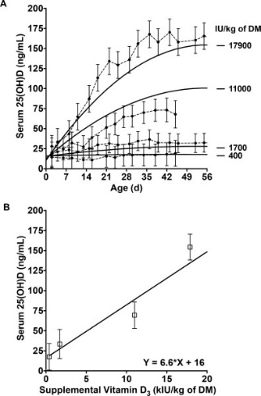

Figure 2. (A) Predicted (solid lines) and observed (dashed lines) serum 25-hydroxyvitamin D [25(OH)D] concentrations of experimental calves in response to rate of supplemental vitamin D3 and day of age. Data represent the outcome of 2 experiments where Holstein bull calves were fed milk replacers containing the increasing amounts of supplemental vitamin D3. In experiment 1, calves were fed milk replacer containing 1,700 (n = 16) or 17,900 IU of vitamin D3/kg of DM (n = 8). In experiment 2, calves were fed 400 (n = 12) or 11,000 IU of vitamin D3/kg of DM (n = 12). Data points and error bars represent the mean and 95% CI for each group according to day of age. The equation of the predicted response was [25(OH)D] = 16.02 ng/mL + (−0.00031 × IU of vitamin D3) + (−0.024 × d) + (0.00029 × IU of vitamin D3 × d) + (−2.59 × 10−6 × IU of vitamin D3 × d2). (B) The solid line represents the slope and intercept of the regression analysis of serum 25(OH)D concentrations of samples collected at 30 d of age and older as a function of supplemental vitamin D3. The slope (6.6 ng/mL per kIU of vitamin D3) and intercept (16.1 ng/mL) were significant (*P* < 0.001). The symbols and error bars represent the observed means with 95% CI of samples from calves in each group at 30 d of age and older.

With daily supplemental vitamin D3 alone, serum 25(OH)D gradually increases over a period of 2 to 3 wk ([Figures](https://www.sciencedirect.com/science/article/pii/S002203021630707X#fig0020) 1 and 2). A more rapid increase during that critical period of a calf’s life would seem beneficial, particularly for those born with extremely low serum 25(OH)D. Similar to what was done for daily supplemental vitamin D3, the response of calves to a bolus injection of vitamin D3 at birth was modeled using data from multiple experiments. The regression line for serum 25(OH)D at 7 d after injection with vitamin D3 predicted an increase of about 30 ± 8 ng/mL (slope ± 95% CI, *P* < 0.001) for every 100,000 IU of vitamin D3 administered starting from a baseline serum 25(OH)D of 11 ng/mL ([Figure](https://www.sciencedirect.com/science/article/pii/S002203021630707X#fig0030) 3).

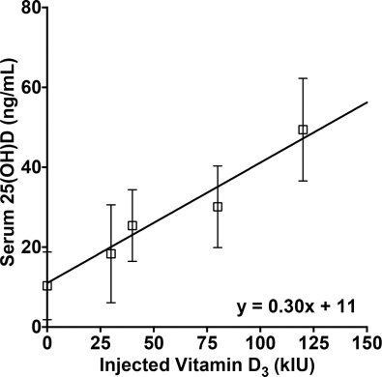

Figure 3. Prediction of serum 25-hydroxyvitamin D [25(OH)D] in response to subcutaneous vitamin D3 injection. In 3 separate experiments, calves were administered various amounts of vitamin D3 via [subcutaneous injection](https://www.sciencedirect.com/topics/agricultural-and-biological-sciences/subcutaneous-injection) at birth and serum 25(OH)D was measured at 7 d of age. In the first experiment, Holstein bull calves received 0 (n = 6) or 30,000 IU of vitamin D3 (n = 3). In the second experiment, Holstein bull calves received 0 (n = 8), 80,000 (n = 5), or 120,000 IU (n = 3) of vitamin D3. In the third experiment, Holstein bull and heifer calves received saline injection or 40,000 IU of vitamin D3 from a commercially available vitamin A, D, and E solution (n = 7/group). In each experiment, calves were fed pasteurized waste milk without any supplemental vitamin D3. The symbols and error bars represent the means with 95% CI of serum 25(OH)D measured in samples collected at 7 d postinjection for each amount of vitamin D3 injected. The solid line represents regression line with a slope and intercept of (0.3 ng/mL per kIU of vitamin D3) and intercept (11.0 ng/mL) that were significant (*P* < 0.001).

[Krueger et al. (2014)](https://www.sciencedirect.com/science/article/pii/S002203021630707X#bib0080) reported a similar response where serum 25(OH)D of calves injected with 40,000 IU of vitamin D3 at birth increased from approximately 20 ng/mL at birth to 40 ng/mL 7 d later. Those calves were fed pasteurized waste milk and, in the absence of continued vitamin D supplementation, their serum 25(OH)D dropped to 30 ng/mL after 14 d and 15 ng/mL at 35 d. In a separate study, those authors showed that calves given 150,000 IU of injectable vitamin D3 at birth followed by 5,000 IU of supplemental vitamin D3/d (~7,500 IU of vitamin D3/kg of DM, in combination with [vitamins A](https://www.sciencedirect.com/topics/agricultural-and-biological-sciences/retinol) and E) increased from an average serum 25(OH)D of 30 ng/mL at birth to near 100 ng/mL at 7 and 14 d of age ([Krueger et al., 2016](https://www.sciencedirect.com/science/article/pii/S002203021630707X#bib0085)). In contrast, serum 25(OH)D of control calves dropped from 30 ng/mL at birth to less than 20 ng/mL at 14 d of age. Ultimately, those authors demonstrated that a bolus injection of vitamin D3 at birth followed by daily supplemental vitamin D3 is an effective means of increasing serum 25(OH)D of calves. Assuming an initial 25(OH)D concentration of 15 to 25 ng/mL for most calves at birth, and depending on the rate of daily supplemental vitamin D3, an initial injection of 50,000 to 100,000 IU of vitamin D3 at birth should be adequate to achieve vitamin D sufficiency. Caution must be used, however, with injectable vitamin formulations, as most products on the market contain vitamins A, D, and E in various combinations. [Intramuscular injections](https://www.sciencedirect.com/topics/agricultural-and-biological-sciences/intramuscular-injection) of excessive vitamin A (i.e., 2 × 106 IU) caused the development of hyena disease in calves ([Takaki et al., 1996](https://www.sciencedirect.com/science/article/pii/S002203021630707X" \l "bib0175); [Woodard et al., 1997](https://www.sciencedirect.com/science/article/pii/S002203021630707X#bib0210)). Data from the experiments reported by [Krueger et al. (2014](https://www.sciencedirect.com/science/article/pii/S002203021630707X#bib0080), [2016](https://www.sciencedirect.com/science/article/pii/S002203021630707X#bib0085)) also indicate that bolus vitamin A injections are not necessary if adequate vitamin A is provided in the diet. Consequently, use of injectable vitamin products should carefully consider the background, diet, and management of the calf.

The serum 25(OH)D concentrations that support optimal growth and health of calves are not yet fully known; thus, recommendations for supplemental vitamin D should not be viewed as definitive at this time. Concentrations below 30 ng/mL of serum have been proposed as a good benchmark for insufficiency ([Norman, 2008](https://www.sciencedirect.com/science/article/pii/S002203021630707X#bib0140); [Adams and Hewison, 2010](https://www.sciencedirect.com/science/article/pii/S002203021630707X#bib0005)). Conversely, calves with average serum 25(OH)D above 170 ng/mL were not protected from respiratory syncytial virus infection better than calves with 30 ng/mL serum 25(OH)D. Future experiments need to examine more fully the relationship between serum 25(OH)D, disease incidence (epidemiological and experimental diseases), vitamin D-associated immune functions (nitric oxide and β-defensin production of macrophages), and overall production. For the time being, a moderate range of 40 to 80 ng/mL of serum 25(OH)D seems to be a reasonable range based on serum 25(OH)D concentrations of calves on summer pasture. Milk replacers often contain about 11,000 IU of vitamin D3/kg of DM, which somewhat exceeds serum 25(OH)D of calves on pasture but is satisfactory based on current state of knowledge. In contrast, producers that raise calves on milk need to adopt the practice of adding supplemental vitamin D3, as discussed. In addition, a bolus vitamin D supplement at birth would help to quickly increase the vitamin D status of newborn calves.

**Conclusions of study**

The current practices for dietary vitamin D3 supplementation in the dairy industry seem to be adequate for cows and heifers, with the 25(OH)D concentrations of most animals ranging between 50 to 80 ng/mL of serum. In fact, supplementing cows at rates well above the NRC recommendation of 21,000 IU of vitamin D3/d for mature cows, such as 40,000 to 50,000 IU/d, may be more than necessary. In contrast, supplementation with 21,000 IU/d may not be adequate based on limited observations reported here. Future research needs to explore the relationship between supplemental vitamin D3 and serum 25(OH)D of dairy cows with regards to key endpoints of disease incidence, fertility, and milk production, along with consideration of the long-term effects of high serum 25(OH)D concentrations that occur in a portion of cows under current practices. In regard to dairy calves, the amount of vitamin D3 in typical milk replacers is adequate but needs to be studied further to determine amounts needed for optimal growth and health. Calves raised on a milk diet, however, are prone to vitamin D deficiency, as milk is very low in vitamin D content. It is recommended that producers raising calves on milk should provide supplemental vitamin D3 at a rate of 6,000 to 10,000 IU/kg of DM. A 50,000 to 100,000 IU bolus of vitamin D3 at birth, whether calves are fed milk or milk replacer diets, would also help to quickly achieve vitamin D sufficiency in newborn calves. Altogether, the recommendations provided here are intended to maintain vitamin D sufficiency as defined by serum 25(OH)D concentrations. Additional research is needed to identify whether correlations exist between serum 25(OH) D and health and productivity of cattle.

https://www.sciencedirect.com/science/article/pii/S002203021630707X#fig0010

* + 1. **Results of study Khalek et al., 2010) on ewe performance**

Milk production: Results presented in Table 2 revealed insignificant effect of treatment on average daily milk yield of ewes. However, among all milk contents, only fat percent in milk of ewes in G2, G3 significantly (P<0.05) increased as compared to the control milk (G1). Meanwhile, milk of ewes in G4, G5 and G6 did not differ significantly than in G1.

It is worth noting that ewes in G3 treated with AD3E showed the highest milk yield and fat content, indicating the highest fat yield from ewes in this group as compared to other treatment and control groups. Such trend may be due to synergistic effect of vitamins A, D and E.Estimates of the amount of milk produced by lactating ewes provide information for the implementation of optimum management and feeding strategies for ewe and their lambs (Cardellino and Benson, 2002). Generally, milk yield of dairy ewes was affected by number of suckling lambs during pregnancy or lactation (Treacher, 1978), type of birth, single, twins or triplets (Snowder and Glimp, 1991), lambing season (Hamdon, 2005) or lactation period length (Morsy, 2002).

Table (2): Effect of treatment on average daily milk yield (g) and milk composition of ewes during up to 45 days of lactation

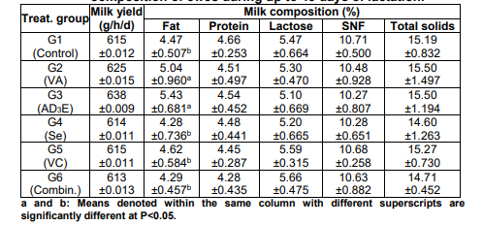

**Conclusion of study**

Treatment of ewes prior to breeding September breeding season with antioxidant such as vitamins (A, AD3E or C), selenium or their combination had impact on lamb and milk production during breeding season, with the best results for ewes treated with vitamin A

C:/Users/KAWA%20IT/Desktop/Documents/JAPPMU_Volume%204_Issue%209_Pages%20513-531.pdf

* + 1. **Result study of Y.M. Hafez** **Effect of treatments on:- Milk yield:**

Milk yield for the first 100 days in lactation was higher (P<0.05) for G2, G3 and G4 than G1 by about 20% (Table 3). This result is in consistence with results of Sklan et al. (1994) who reported an increase in milk yield between10 and 16% for multiparous and primiparous cows, respectively, supplemented with 2.5% calcium soaps of fatty acid over the requirements of total mixed ration relative to the control group. Effect of vitamins on milk yield, results of Oldham et al. (1991) and Panda et al. (2006) agree in trend with the present results (Table3) ). Panda et al. (2006) reported a significant increase in milk yield by 12, 28 and 25% over the control group when Murrah buffaloes treated with 1000, 1500 and 2000 IU of vitamin E (α-tocopheryl acetate) from 60 days prepartum to 30 days postpartum and 500, 750 and 1,000 IU from 30 to 60 days postpartum, respectively. Similar results were observed in Holstein cows as reported by Oldham et al. (1991) who found a significant increase of 12 % in milk production when cows were supplemented with 170,000 IU of vitamin A supplementation began 14 days before drying off and continued through 6 wks postpartum) compared to the control group given the NRC(1989) requirements of vitamin E.

Table 3. Mean (LSM±SE) milk yield and fat corrected milk yield and different milk components for the first 100 days of lactation of buffalo fed protected fat (G2) ration or injected with vitamin AD3E (G3) or both (G4) relative to control (G1)

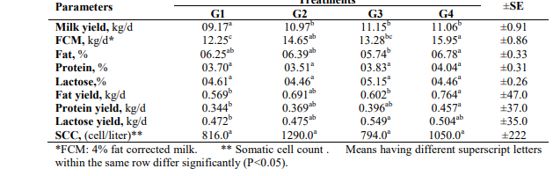

**Conclusion of study**

The manipulation of the periparturient investigated schemes of the dietary supplementation for lactating buffaloes has a positive effect on milk production efficiency leading to an increase in their milk yield, and better feed conversion without negative effects on milk components.

* + 1. **Result of study (Shinde1 et al., 2021)**

Effects on Milk yield

The present experiments were performed with dietarysupplementation of area specific mineral mixture and Vitamin AD3E to find out whether it have any effect or any change on milk yield, Fat%, SNF% and benefit cost ratio in dairy cattle in Betul district. The observations on milk yield and Fat% & SNF% in dairy cattle are presented in Table-4. The average milk yield for 1-100 days in treatment group T2 was found significantly higher (p<0.05) as compared to its yield observed in T1 and control group. These finding were in agreement with the results reported by Srivara (2019) and Gupta et al. (2017) in crossbred cattle. Pandey et al. (2018) also reported increase in milk yield due to supplementation of area specific mineral mixture in dairy cattle. Feeding of area specific mineral mixture increased milk yield 25% in field trials (Tiwari et al., 2013). Similar findings observed by Hackbart et al. (2010), who found increased milk production at 14 week supplementation of organic trace minerals to cattle. The supplementation of TANUVAS – mineral mixture to a dairy cattle resulted in increase in milk yield by 1.46 ± 0.14 and one litre per day in cow respectively (Akila et al., 2013 and Senthilkumar et al., 2016). (Sahoo et al. 201)and Singh et al., 2020 also found increased milk yield by supplementation of area specific mineral mixture in dairy cattle of the hilly region. Significantly higher (p<0.05) milk production in supplemented animal with mineral mixture and vitamin indicating that supplementation attributes improved milk production potential of cattle could be due to having impact on the mammary myoepithelial cells in the udder during lactation. Further, synergistic effect of mineral mixture and vitamin contribute in the working of memory cells to enhance their productivity. This finding was in accordance with Ghosh et al. (2016) observation. Our finding is in supports of Yang et al. (2011) reported positive effect of vitamin and trace element on milk performance of cattles. Furthermore, we found significant increase in Milk fat %

and SNF% in diets supplemented with area specific mineral mixture and vitamin AD3E than control and onlyvitamin supplemented group, while Mohsina et al. (2017)observed no significant differences in milk fat % and milkSNF % between the supplemented and non-supplemented mineral mixture in groups of animals. This might be due to synergistic effect of we supplemented mineral mixture and vitamin together. Cost of milk production and Benefit Cost ratio (BCR) The economic analysis of the data showed that dietary supplementation of Vitamin AD3 E (T1) and combination of Vit AD3 E & area specific mineral mixture (T2) enhances the milk yield by 13.94 % and 31.60% per day respectively than the control group. It could be inferred from Table 5 that benefit cost ratio was higher (p<0.05) in vitamin and ASMM supplement animals as compared to only vitamin

supplemented and control group. The feeding cost of per litre of milk was significantly lower (` 16.43) in T2 group as compared to (` 17.24) in T2 group and (` 18.54) in control group. Gross return from sale of milk in T2, T1 and Control group were ` 340.8, ` 287.60 and 258.80 respectively and net profit per litre of milk was found to behigher in T2 group (` 23.56) than T1 group (` 22.75) and control group (` 21.45). The Benefit Cost ratio was also found higher in treatment group T2 (` 2.43) as compared to T1 (` 2.31) and control group (` 2.15). Similar result to the present finding was in accordance with Singh et al. (2020) and Srivara (2019) in milch cattle.

**Conclusion of study**

It may be concluded from the present study that dietary supplementation of combination of area specific mineral mixture and vitamin AD3 E to the lactating dairy cattle under field conditions not only increases the milk yield, but also increase Fat% & SNF% and reduce cost per litre of milk production and consequently improving socioeconomic conditions of smallholders’ dairy farmer in tribal district like Betul.

Table 4. Nutrient composition and energy value of ingredients and rations

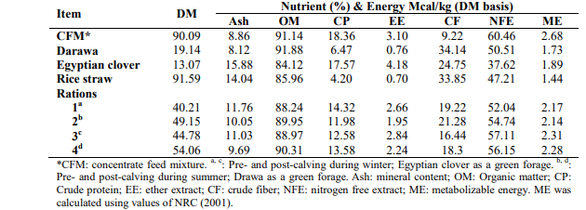

Table 5.. Mean (LSM±SE) milk yield and fat corrected milk yield and different milk components for the first 100 days of lactation of buffalo fed protected fat (G2) ration or injected with vitamin AD3E (G3) or both (G4) relative to control (G1)

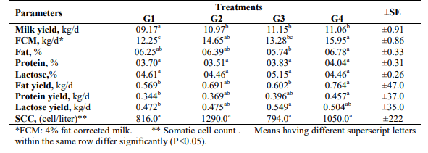

file:///C:/Users/KAWA%20IT/Desktop/Documents/EfficacyofAreaSpecificMineralMixtureandVitaminAD3.pdf

file:///C:/Users/KAWA%20IT/Desktop/Documents/EJAP_Volume%2049_Issue%203_Pages%20249-256.pdf

* + 1. **Result of study (Islam et al., 2015)**

Milk yield

The mean daily milk production of indigenous cow at before nutritional supplement were 1.5 ± 0.1 litres and after deworming and nutritional supplementation over a moth milk yield were increased to 2.3 ± 0.02 litres (Table 6): the differences were significant (p<0.001). The finding were consistent with the value of 2.1±0.41litres reported by [35] in other part of Bangladesh. This result was slightly lower than the findings of [36] where, daily milk production of indigenous and crossbred cow was 2.6 and 4.9 litres, respectively. Results also partially agree with those of [42]; [37] and [26].

The milk yield was significantly (p<0.001) affected by feeding intervention which is similar to the findings with the [42] who observed that feeding significantly (p<0.01) increased the milk yield in indigenous cow and also reported by [43] in crossbred cows in Bangladesh. Milk yield is highly heritable, as cows produce more milk either by using ingested food or by mobilizing body fat [44]. Management and nutrition are important for milk production and fertility [45; 46].

Table 6: Average milk production and body weight in cows From: [Reproductive Performances and Management Effects on Productions of Indigenous Dairy Cows Raised at *Char* Areas in Northern Bangladesh](https://link.springer.com/article/10.7603/s40871-015-0007-x)

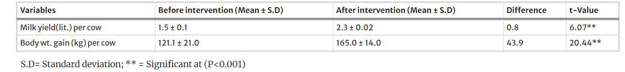

**Conclusions of study**

The present study estimate the long calving interval is the indicator of poor reproductive performance of indigenous cows on *Char* areas. It may be concluded that factors contributing to this situation seem to be mal-factorial; accessibility to breeding bull, poor heat detection, poor nutrition, late resumption of ovarian activity and risk of abortion and peripartum disorders (dystocia, retention of fetal membrane). Delivery of productive veterinary health care services significantly (p<0.001) improved cows' health and increased milk production. Further detailed investigation is necessary to identify and quantify the specific reproductive disorders attributing to such poor performance.

<https://link.springer.com/article/10.7603/s40871-015-0007-x>