Curriculum Vitae
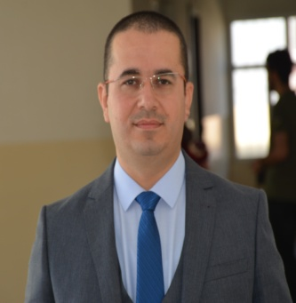
I. Personal data
- Name: Twana Ahmed Mustafa
- Gender: Male
- Nationality: Iraqi
- Native Language Kurdish
- Address: Mufti, Erbil, Iraq
- Mobile phone No.: 0750 494 3099
- E-mail address: dr.twana@epu.edu.iq
- Academic title:
- Assist. Prof. at 25/3/2018
- Lecturer at 10/11/2013
- Assist. Lecturer at 7/1/2008
- Job:
- Assist. Head of MLT Department-Erbil Medical institute 2008-2009
- Head of MLT department- Erbil Health Technical College 2014-2019
- Member of the EPU committee to promote the scientific title since 2016
- Head of Medical section for Higher education

- Place and date of birth: Erbil, 27/2/1982
- Marital Status: Married
- Duration of employment: 12 years

II. Education
- Ph.D. in Cytology, College of Science Education / Salahaddin University, Erbil, Iraq (2013).
- Master Degree in Microbiology, Salahaddin University, Erbil, 2007.
- B.Sc. in Biology, College of Science, Salahaddin University, 2004.
- Graduated from Rizgary Preparatory School, Erbil, 2000.

III. Summary of employment and experience.
- Central public laboratory/ Erbil city
- Assistant Head of MLT Department in Medical Technical Institute/Erbil in 2008.
- Members of Kurdistan Biology syndicate-2005
- Members of Kurdistan Teachers syndicate-2010.
IV. Skills:
- Kurdish: Excellent
- Arabic: Very Good
- English: Very Good
- Leadership: Very Good

