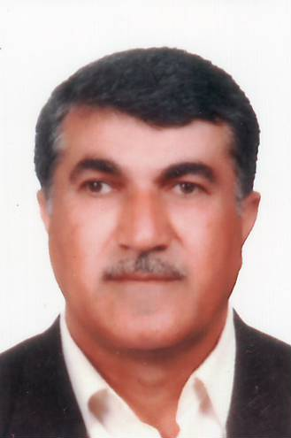
CURRICULUM VITAE

Personal Data
1-Full name Samih kakamam Hassan
2-Date of birth& place 1/7/1957 Altun kopri -Kirkuk
3-Gender Male
4-Marital state Married
5-addrees Zanko -Erbil –Iraq
Tel .No 009647504467413
E. mail dr.alkalhuri@yahoo.com , alkalwuri@gmail.com
Languages Kurdish, Arabic, English, Turkish.

Qualification (Education)
- M.B.CH.B. medical collage Baghdad university 1983- 1990
- Master degree ( High Diploma ) in orthopedic &traumatology, salahadden university, 2002

Specialization
- Orthopaedic &traumatology surgeon in Erbil Teaching Hospital.

Assistant lectrur in Hawler Polytechnic University .

Head of orthopedic and Traumatology in Erbil Teaching Hospital 2011-2016.

Training course
- orthopedic training course( international medical Corps ) Erbil –Iraq 25-28 august - 2008
- ilizarov training course 3-5 June 2011 – Turkey
- Advances course in operative fracture management( AO Education ) 7-10 july,Erbil, Iraq 2011
- DAA Surgical course featuring Accolade, ABGII& Trident (cadaver course) on a pril 25-26 -2013 INNSBRUCK, Austria.
- Intermediate Arthroplasty Course 26th – 28th October 2013, Bursa – Turkey (smith&nephew).
- Basic knee arthroscopy course 14-15 Decemder2o13 Erbil Teaching Hospital –Iraq
- Training Program me in Quality Assurance for Health improvement between May –December 2013 Erbil -Iraq
- Work shop in sub acromial shoulder Impingement (accredited by Elisabeth Hospital, Uppsala – Sweden 16 January 2014Erbil Teaching Hospital –Kurdistan region – IRAQ .
- Mena Knee arthroplasty complex primary to revision knee course Turkey 2014.
- Total hip replacement and total knee replacement Cadaver course Sharjah University Dubai May-2015.
- Pediatic spinal deformity course in (4-5 April Acibadem hospital –Turkey.

Scientific conferences
- 10th Annual Conference of the Arab Hospital federation 13-16 Amman –Jordan 2012
- Iraq health Summit organized by naseba communications FZLLC on march 10th -11th at Erbil Rotana ,Erbil ,Iraq. 2013
- 14th congress of the EFFORT HELD IN Istanbul-Turkey 5-8 June 2013.

Assignments &post (Job Experience)
- Orthopedic surgeon in hawler teaching hospital.
- Lecturer in medical technical institute – Hawler Polytechnic University Erbil 2005-2006.
- Head of physiotherapy dept. in medical technical institute -– Hawler Polytechnic University Erbil 2007-2011.
- Head of dept. orthopaedic & traumtology- Hawler teaching Hospital 2011-2016.
- Assistant director of Erbil teaching hospital 2011 – 2016.
- Director of Quality Assurance in Erbil Teaching Hospital 2012-2016
- AO member
- ISKSAA - member
- ESSKA - member
- Kurdistan orthopedic association-Iraq
Computer programs
Windows, Word, Excel, power point

