Dlshad Saadallah Othman
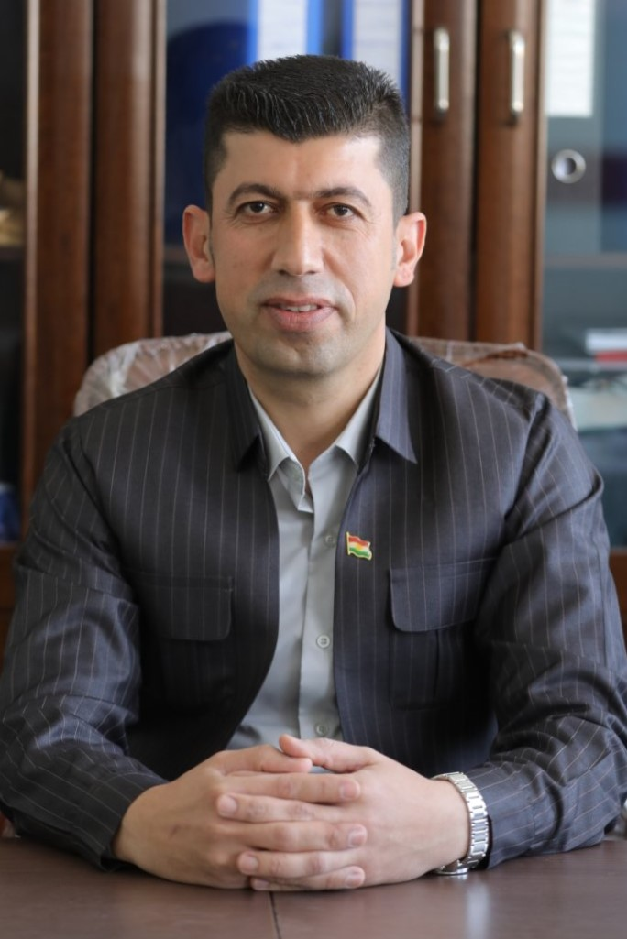
Address: Taqtaq, Koya, Erbil, Kurdistan Region, Iraq
Phone: 07501203648-07704464514
Email: dlshad.othman@epu.edu.iq
Dilshad.saadulla@gmail.com

EDUCATION
ـــــــــــــــــــــــــــــــــــــــــــــــــــــــــــــــــــــــــــــــــــــــــــــــــــــــــــــــــــــــــــــــــــــــــــــــــــــــــــــــــــــــــــــــــــــــ
2021-Until now Working as assistant researcher at MLT department, and as Head Department
Of MLT/Taqtaq Department Koya Technical Institute from 1/10/2021.

2021-present Working as assistant researcher at MLT department, and as coordinator
Of MLT/Taqtaq Department Koya Technical Institute from 17/10/2019.

2015-2017 University of Van Yuzuncu Yil/Turkey
Biology dept. faculty of Medical
MSc Parasitology
Models Include Topics in biology, Advanced Research Methods,
Medical Parasitology, Advanced Statistical Methods,
Pathology of parasite, stain Parasitology, Advanced Immunology and Serology, General Parasitology, Molecular Parasitology, Arthropod, Treatment of pathological parasites and Diagnosis of Medical Parasitology.

2004-2005 University of Koya
Koya, Erbil, Kurdistan Region, Iraq
B.A Education in Biology .
2003-2004 koya technical institutes
Diploma in MLT Department

EMPLOYMENT AND WORK EXPERIENCE
ـــــــــــــــــــــــــــــــــــــــــــــــــــــــــــــــــــــــــــــــــــــــــــــــــــــــــــــــــــــــــــــــــــــــــــــــــــــــــــــــــــــــــــــــــــــــــــ
2021-until now I worked as a Head Department of MLT Taqtaq department at Koya Technical Institute.
2019- 2021 I worked as a Coordinator of MLT department at Koya Technical Institute.

2017-2019 I worked as an Master /Advance biologist in Laboratory Taqtaq General
Hospital and extra letterer In koya technical institute

2008-2017 I worked as an Advance biologist in Laboratory Taqtaq General Hospital

2005-2008 I worked as an assistant lab technician in Laboratory Taqtaq General Hospital

RESEARCH INTERESTS
ـــــــــــــــــــــــــــــــــــــــــــــــــــــــــــــــــــــــــــــــــــــــــــــــــــــــــــــــــــــــــــــــــــــــــــــــــــــــــــــــــــــــــــــــــــــــــــــــ
- I am interested in Microbiology, Parasitology and Lab technology.

SKILLS AND XEPERINCE
ــــــــــــــــــــــــــــــــــــــــــــــــــــــــــــــــــــــــــــــــــــــــــــــــــــــــــــــــــــــــــــــــــــــــــــــــــــــــــــــــــــــــــــــــــــــــــــــــ

- Using software programs in Biological Research
(SPSS, Graph pad, excel, power point ).

- I participated in the Computer training (ICDL course) from
10/10/2016- 10/11/2016 at Education College – Van Yuzuncu yil
University of Turkey and successfully completed it.

LANGUAGE SKILLS
ــــــــــــــــــــــــــــــــــــــــــــــــــــــــــــــــــــــــــــــــــــــــــــــــــــــــــــــــــــــــــــــــــــــــــــــــــــــــــــــــــــــــــــــــــــــــــــــــــــ

- Kurdish (first language)
- Arabic (good)
- English (Intermediate skill)
- I participated in the English language skill course
, 2015 at Van Yuzuncu Yil university of Turkey and successfully
Completed it.
- I participated in the English language skill course
, 2017 at Koya
University of Kurdistan region-Iraq and successfully
Completed it.
- I participated in the English training course between
2019 at Raparin university of
Kurdistan region-Iraq and successfully completed it.
- Turkish (very good)

ACTIVITIES AND INTERESTS
ـــــــــــــــــــــــــــــــــــــــــــــــــــــــــــــــــــــــــــــــــــــــــــــــــــــــــــــــــــــــــــــــــــــــــــــــــــــــــــــــــــــــــــــــــــــــــــــــــــ

- Reading

- Social activity and friendship

REFERENCES
ــــــــــــــــــــــــــــــــــــــــــــــــــــــــــــــــــــــــــــــــــــــــــــــــــــــــــــــــــــــــــــــــــــــــــــــــــــــــــــــــــــــــــــــــــــــــــــــــــ

- References available on request

