

Ministry of higher education and scientific research

Erbil polytechnic university

Shaqlawa technical college

Department of Nursing

Morning Classes

Grade “2”

Graduation project(Research)

Assess Nurses Knowledge regarding Lung cancer in Erbil Hospital

**Prepared by:**

Zelan Edrees

Sarwin Ghafur

Sara Rasul

Fatema Sabr

**Supervised by:**

Mr. Dler M. Saeed

2022 – 2023

***Supervisor's Certification***

*I certify that this thesis was prepared under my supervision at Erbil polytechnic university, Shaqlawa Technical College, Nursing Department in partial fulfilment of the requirements for the degree of diploma of Science in Nursing.*

**Lecturer**

Dler M. Saeed

Nursing Department

Shaqlawa Technical College

Erbil polytechnic university

(2022-2023)

Hashem H. Abdullah

Head of Nursing Department

Shaqlawa Technical College

Erbil polytechnic university

(2022-2023)

***Acknowledgement***

*Before all, greatest thanks to Allah the glorious merciful and the compassionate. we would like to express our sincere thanks gratitude to our supervisor Dr.Dler Muhammad for his guidance and help. We would like to express our thanks for Mr. Hashm Hamad, Head of Nursing Department Finally we want to express our appreciation to all samples who participated in the study.*

*Zelan Edrees*

*Sarwin Ghafur*

*Sara Rasul*

*Fatema Sabr*

**COMMITTEE CERTIFICATE**

We, the members of the Examining Committee certify that, after reading this thesis and examining the student in its contents, it is adequate for the award of the degree of Diploma in Nursing Science.

**Signature:**

Member

Dler M. saeed

Assistant Lectures

Nursing Department  **Signature:**

Shaqlawa Technical College Chairman

Erbil Polytechnic University Nihayet. Shekh

Date:17/4/2023 Assistant Lecture

Nursing department

**Signature:**  Shaqlawa Technical College

Member Erbil Polytechnic University

Khanzad A. Pirdawood

Nursing Department

Shaqlawa Technical College

Erbil Polytechnic University

Date:17/4/2023

________________________________________________________________

Approved by the council of the Erbil polytechnic university, Shaqlawa

Technical College, Nursing Department.

**Hashem H. Abdollah**

Head of Nursing Department

Shaqlawa Technical College

Erbil polytechnic university

Date: 17/4/2023

**Abstract**

Lung cancer is a disease in which the growth of lung cells gets out of control. Lung cancer is initially asymptomatic and then shows several symptoms.Lung cancer is the second most common cancer in men and women in the United States. it can be treated with surgery, radiotherapy and chemotherapy depending on the type of cancer cells. Nurses has an important role in the health care team and specially it is supposed to have an excellent knowledge about cancer. We designed a descriptive cross sectional survey which aimed to measure knowledge of nurses who are working in the Erbil hospitals. Knowledge nurses assessed via using a self designed questionnaire which include demographic data and 15 questions which measure knowledge of nurses regarding cancer.The results of the study showed that nurses have an acceptable knowledge (73.33% ) about lung cancer, but still we need to design and implement some measures to maintain and improve their knowledge.

**Contents list**

Abstract................................................................................................................3

List of content ..................................................................................................4-5

**Chapter one** ....……...………………………………………………………6-13

Introduction .....……...………………………………………………………….7

Objective of the study ...……...…………………………………………………7

Review of literature ...……...………………………………………………..8-13

What is lung cancer… ? ...……...……………………………………………….8

Symptoms ...……...……………………………………………………………..8

Type of lung cancer...……...……………………………………………………8

Where does lung cancer spread.....……...………………………………………9

Risk factors.....……...………………………………………………………….10

Prevention ...……...……………………………………………………………11

Diagnosis of lung cancer …………………………………………………..11-12

Treatment ...……...…………………………………………………………12-14

Nursing intervention …...……...………………………………………………14

**Chapter two .**..……...…………………………………………………………16

Methodology ...……...…………………………………………………………16

Design of the study .....……...…………………………………………………16

Duration of the study ...……...………………………………………………...16

Sample of the study .....……...………………………………………………...16

Setting of the study…...……...………………………………………………...16

Method and tool of data collection......……...…………………………..……..16

Ethical consideration ...……...………………………………………………...16

Statistical analysis …....……...………………………………………………...16

Source of women knowledge….……………………………………………….16

**Chapter three** ….………………………………………………………….18-20

Result ….…………………………………………………………………...18-20

**Chapter four** .….…………………………………………………………..21-22

Discussion .….…………………………………………………………………22

**Chapter five**….…………………………………………………………….23-24

Conclusion….………………………………………………………………….24

Recommendation ….…………………………………………………………..24

پوختە….…………………………………………………………………………25

………………………………………………………………………….26الخلاصة

Reference...….…………………………………………………………………27

Chapter one

**Introduction**

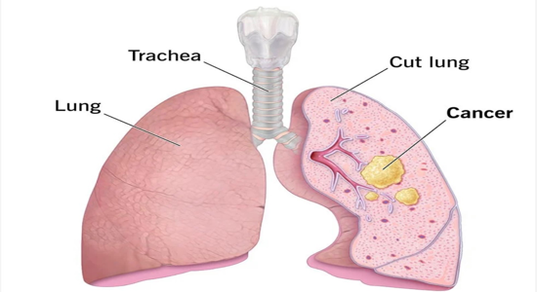

Cancer is a disease in which cells in the body grow out of control. When cancer starts in the lungs, it is called lung cancer..Different people have different symptoms for lung cancer. Some people have symptoms related to the lungs. Some people whose lung cancer has spread to other parts of the body (metastasized) have symptoms specific to that part of the body. Some people just have general symptoms of not feeling well. Most people with lung cancer don’t have symptoms until the cancer is advanced. Lung cancer symptoms may include: Coughing that gets worse or doesn’t go away, Chest pain, Shortness of breath, Wheezing,Coughing up blood, Feeling very tired all the time Weight loss with no known cause.The American Cancer Society's estimates for lung cancer in the United States for 2022 are: About 236,740 new cases of lung cancer (117,910 in men and 118,830 in women) About 130,180 deaths from lung cancer (68,820 in men and 61,360 in women.

Lung cancer is the leading cause of cancer death. Not counting some kinds of skin cancer, lung cancer is the second most diagnosed cancer in both men and women in the United States. After increasing for decades, lung cancer rates are decreasing nationally, as fewer people smoke cigarettes and as lung cancer treatments improve. People with lung cancer are living longer after their diagnosis because more cases are found early, when treatment works best.This is why we chose this topic to find out the level of knowledge and awareness of nurses about this disease.

**Objective**

1. To assess Erbil’s Nurses knowledge about lung cancer
2. To assess socio-demographics data of participants

**Review of literature**

**1.2. What is lung cancer…?**

Cancer is a disease in which cells in the body grow out of control. When cancer starts in the lungs, it is called lung cancer. Lung cancer begins in the lungs and may spread to lymph nodes or other organs in the body, such as the brain. Cancer from other organs also may spread to the lungs. When cancer cells spread from one organ to another, they are called metastases. Lung cancers usually are grouped into two main types called small cell and non-small cell (including adenocarcinoma and squamous cell carcinoma). These types of lung cancer grow differently and are treated differently. Non-small cell lung cancer is more common than small cell lung cancer.

**1.3. Symptoms**

Lung cancer typically doesn't cause signs and symptoms in its earliest stages. Signs and symptoms of lung cancer typically occur when the disease is advanced.Signs and symptoms of lung cancer may include:

* A new cough that doesn't go away
* 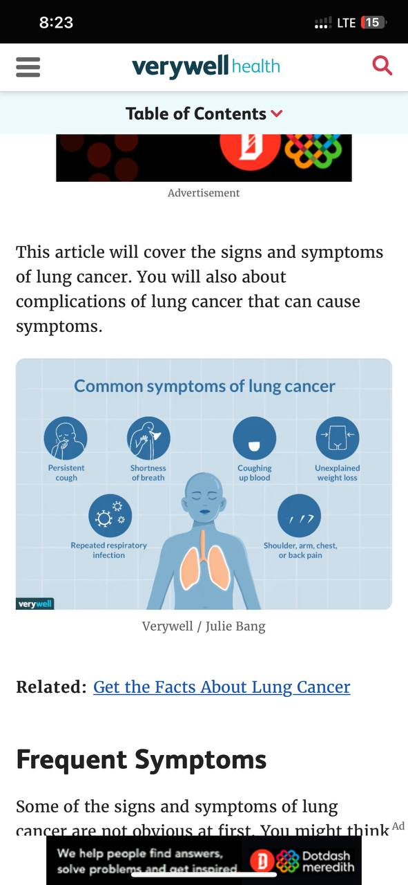Coughing up blood, even a small amount
* Shortness of breath
* Chest pain
* Hoarseness
* Losing weight without trying
* Bone pain
* Headache

**1.4. Types of lung cancer**

**The two general types of lung cancer include:**Small cell lung cancer: Small cell lung cancer occurs almost exclusively in heavy smokers and is less common than non-small cell lung cancer.Non-small cell lung cancer: Non-small cell lung cancer is an umbrella term for several types of lung cancers. Non-small cell lung cancers include squamous cell carcinoma, adenocarcinoma and large cell carcinoma.

**1.5. Where does lung cancer spread?**

When lung cancer spreads, or metastasizes, it can move to nearby tissues or to more distant areas in the body. While it’s possible for lung cancer to spread virtually anywhere, it most commonly metastasizes in the liver, brain, bones or adrenal glands.

**1.5.1Lymph Nodes**

Most lung cancers first spread to lymph nodes within the lung or around the major airways.4 Lymph nodes are tiny organs clustered throughout the body that trap and filter foreign substances.

**1.5.2 Bone**

One of the more serious complications of NSCLC is lung cancer metastases to bones. Roughly 30% to 40% of people with advanced lung cancer will develop this.

**1.5.3Brain**

Lung cancer is the most common cancer that spreads to the brain. In fact, as many as 40% of people with lung cancer will develop brain metastases at some point. This can occur with both NSCLC and SCLC but is known to develop rapidly with SCLC.

**1.5.4 Liver**

Lung cancer that has spread to the liver is common and can affect anywhere from 30% to 50% of people with advanced-stage disease.

**1.5.5Adrenal Glands**

Adrenal glands are organs on the top of the kidneys that produce hormones. Lung cancer that spreads to the adrenal glands does not usually cause symptoms and is most often discovered during the routine staging of cancer.

**1.6. Risk factors**

**1.6.1 smoking**

Cigarette smoking is the number one risk factor for lung cancer. In the United States, cigarette smoking is linked to about 80% to 90% of lung cancer deaths. Using other tobacco products such as cigars or pipes also increases the risk for lung cancer. Tobacco smoke is a toxic mix of more than 7,000 chemicals.

**1.6.2 Secondhand Smoke**

Smoke from other people’s cigarettes, pipes, or cigars (secondhand smoke) also causes lung cancer. When a person breathes in secondhand smoke, it is like he or she is smoking.

**1.6.3 Other Substances**

Examples of substances found at some workplaces that increase risk include asbestos, arsenic, diesel exhaust, and some forms of silica and chromium. For many of these substances, the risk of getting lung cancer is even higher for those who smoke. Living in areas with higher levels of air pollution may increase the risk of getting lung cancer.

**1.6 .4 Personal or Family History of Lung Cancer**

If you are a lung cancer survivor, there is a risk that you may develop another lung cancer, especially if you smoke. Your risk of lung cancer may be higher if your parents, brothers or sisters, or children have had lung cancer. This could be true because they also smoke, or they live or work in the same place where they are exposed to radon and other substances that can cause lung cancer.

**1.6.5Radiation Therapy to the Chest**

Cancer survivors who had radiation therapy to the chest are at higher risk of lung cancer.

**1.7 Prevention**

Not all lung cancers can be prevented. But there are things you can do that might lower your risk, such as changing the risk factors that you can control.

**1.7.1 Stay away from tobacco**

The best way to reduce your risk of lung cancer is not to smoke and to avoid breathing in other people’s smoke.

**1.7.2 Avoid radon exposure**

Radon is an important cause of lung cancer. You can reduce your exposure to radon by having your home tested and treated, if needed. For more information, see Radon and Cancer.

**1.7.3 Avoid or limit exposure to cancer-causing agents**

Avoiding exposure to known cancer-causing agents, in the workplace and elsewhere, may also be helpful. When people work where these exposures are common, they should be kept to a minimum.

**1.7.4 Eat a healthy diet**

A healthy diet with lots of fruits and vegetables may also help reduce your risk of lung cancer. Some evidence suggests that a diet high in fruits and vegetables may help protect people who smoke and those who don't against lung cancer. But any positive effect of fruits and vegetables on lung cancer risk would be much less than the increased risk from smoking.

**1.8 Diagnosis of Lung Cancer**

**1.8.1 Physical Examination/Assessment**

Sputum Cytology. This determines the presence of abnormal or cancerous cells in the client’s phlegm.

**1.8.2 Mediastinoscopy**

A procedure wherein the physician creates an incision at the base of the neck. The instrument (mediastinoscope) will examine the mediastinum to remove or obtain lymph node samples. It is usually done in a hospital under general anesthesia.

**1.8.3 Imaging tests**

(e.g., MRI, CT scan, PET scans, and X-ray). These scans usually determine whether cancer has metastasized and reveal the presence of abnormal mass.

**1.8.4 Biopsy such as**:

**Needle Biopsy**. This procedure involves the insertion of a needle with imaging guidance, allowing identification of nodule and removal of a tissue sample for histopathologic examination.

**Bronchoscopy.** This test helps observe the client’s airways. A flexible and narrow tube is inserted down the throat and into the trachea to allow for a more thorough examination.

**1.9 Treatment**

Types of Treatment

Lung cancer is treated in several ways, depending on the type of lung cancer and how far it has spread. People with non-small cell lung cancer can be treated with surgery, chemotherapy, radiation therapy, targeted therapy, or a combination of these treatments. People with small cell lung cancer are usually treated with radiation therapy and chemotherapy.

**1.9.1 Surgery**

An operation where doctors cut out cancer tissue.

**1.9.2 Chemotherapy.**

Using special medicines to shrink or kill the cancer. The drugs can be pills you take or medicines given in your veins, or sometimes both.

**1.9.3 Radiation therapy**

Using high-energy rays (similar to X-rays) to kill the cancer.

**1.9.4 Targeted therapy**

Using drugs to block the growth and spread of cancer cells. The drugs can be pills you take or medicines given in your veins. You will get tests to see if targeted therapy is right for your cancer type before this treatment is used.

Doctors from different specialties often work together to treat lung cancer. Pulmonologists are doctors who are experts in diseases of the lungs. Surgeons are doctors who perform operations. Thoracic surgeons specialize in chest, heart, and lung surgery. Medical oncologists are doctors who treat cancer with medicines. Radiation oncologists are doctors who treat cancers with radiation.

**1.9.5 Clinical Trials**

Clinical trials use new treatment options to see if they are safe and effective. For more information, visit the National Cancer Institute’s Clinical Trials page. If you have cancer, you may want to take part. Visit the sites listed below to find a clinical trial.

Complementary medicine is used in addition to standard treatments. Examples include acupuncture, dietary supplements, massage therapy, hypnosis, and meditation.

Alternative medicine is used instead of standard treatments. Examples include special diets, mega dose vitamins, herbal preparations, special teas, and magnet therapy.

**1.9.6 Which Treatment Is Right for Me?**

Choosing the treatment that is right for you may be hard. Talk to your cancer doctor about the treatment options available for your type and stage of cancer. Your doctor can explain the risks and benefits of each treatment and their side effects. Side effects are how your body reacts to drugs or other treatments.

**1.10 Nursing Intervention**

▪ Elevate the head of the bed to ease the work of breathing and to prevent fluid collection in upper body (from superior vena cava syndrome).

▪ Teach breathing retraining exercises to increase diaphragmatic excursion and reduce work of breathing.

▪ Augment the patient’s ability to cough effectively by splinting the patient’s chest manually.

▪ nstruct the patient to inspire fully and cough two to three times in one breath.

▪ Provide humidifier or vaporizer to provide moisture to loosen secretions.

▪ Teach relaxation techniques to reduce anxiety associated with dyspnea. Allow the severely dyspneic patient to sleep in reclining chair.

▪ Encourage the patient to conserve energy by decreasing activities.

Chapter Two

**Methodology**

**2.1. Design of the study:**

A descriptive study was conducted in order to assess knowledge of nurses regarding lung cancer in Erbil.

**2.2. Duration of the study:**

This study performed from (22-10-2022) to (17-4 -2023) .

**2.3. Sample of the study:**

a purposive sample of total 40 nurse. ( 36 nurse in Rizgary Hospital and 4 nurse in west emergency.

**2.4. Setting of the study:**

study was conducted at Rizgary Hospital and west emergency.

**2.5. Method and tool of data collection:**

A questionnaire was prepared to assess Knowledge of Kurdish

Nurse regarding lung cancer in Erbil. Also another special form was prepared to collect biographic data about participants.

**2.6. Ethical considerations:**

The agreement of participants was taken verbally to participate in the study.

**2.7. Statistical analysis:**

Data management and statistical analysis: Data will be reordered on a specially designed questionnaire, collected and included number and percentages of each

category of the questionnaire the results will be presented as numbers & percentage collected data was analyzed by Excel program.

**2.8. Source of nurse knowledge:**

Participants were able to indicate different sources of knowledge whether they are (social media, medical book ,medical lectures, hospitals ).

Chapter Three

Result

|  |  |  |  |
| --- | --- | --- | --- |
|  |  | Table(1) Age |  |
| N | Age | Frequency | Percentage |
| 1 | **20-25** | 9 | 22.5% |
| 2 | **26-30** | 11 | 27.5% |
| 3 | **31-40** | 10 | 25% |
| 4 | **>40** | 10 | 25% |
| 5 | **Average** | 35 | 78.5% |

**Table(1):**

In this research out of 40 nurses according to age , 22%(9) nurses was  between  20 _ 25years , 27.5% (11) nurses was between 26-30 years , 25% (10) nurses was between 31-40 , 25%(10) nurses was above 40. The average age of nurses was (35) which is78.5%.

|  |  |  |  |
| --- | --- | --- | --- |
|  |  | Table (2) Gender |  |
| N | Gender | Frequency | Percentage |
| 1 | Male | 23 | 57.5% |
| 2 | Female | 17 | 42.5% |

**Table(2):**

Out of 40 nurses according to gender, 57.7% (23) was male, 42.5% (17) was female.

|  |  |  |  |
| --- | --- | --- | --- |
|  |  | Table(3) qualification |  |
| N | Qualification | Frequency | Percentage |
| 1 | Diploma | 23 | 57.5% |
| 2 | Bachelor | 17 | 42.5% |

**Table(3):**

Out of 40 nurses according to nurses Qualification, 57.7% (23) was

Diploma ,42.5% (17) was Bachelors.

|  |  |  |  |
| --- | --- | --- | --- |
|  |  | Table(4) work place |  |
| N | Work place | Frequency | Percentage |
| 1 | Rizgary hospital | 36 | 90% |
| 2 | West emergency hospital | 4 | 10% |

**Table(4):**

Out of 40 nurses according to works place , 90% (36) was in rizgary hospital , 10% (4) was in west emergency hospital..

|  |  |  |  |
| --- | --- | --- | --- |
|  |  | Table (5) years of Experience |  |
| N | Years of experience | Frequency | Percentage |
| 1 | <10 | 20 | 50% |
| 2 | 10-30 | 19 | 47.5% |
| 3 | >30 | 1 | 2.5% |
| 4 | **Average** | 14 | 35% |

**Table(5):**

Out of 40 nurses according to Years Of Experience , 50% (20) was between

1_9 ,47.5% (19) was between 10_30 , 2.5% .(1) was above 30.the average years of experience was (14) which is 35%.

|  |  |  |  |
| --- | --- | --- | --- |
|  |  | Table(6) Material Status |  |
| N | Material status | Frequency | Percentage |
| 1 | Married | 20 | 50% |
| 2 | Single | 20 | 50% |

**Table(6):**

Out of 40 nurses according to material state ,

50% (20) nurses was married , 50% (20) nurses was single.

**Cont…. result**

**. Results of nurse Knowledge about questions .**

|  |  |  |  |
| --- | --- | --- | --- |
|  |  | Knowledge nurses |  |
| N | Knowledge | **Frequency** | **Percentage** |
| 1 | 4-7/15 | 4 | 10% |
| 2 | 8- 10/15 | 17 | 40.5% |
| 3 | 11-13/15 | 19 | 49.5% |
| 4 | 14/15 , 15/15 | 0 | 0 % |
| 5 | Average | 11/15 | 73.33% |

**Table(7):**

Out of (40) nurses according to knowledge about lung canser , 10% They answered 4-7 questions correctly out of 15 questions. They had a poor level of knowledge about lung canser., 40.5% They answered 8-10 out of 15 questions correctly. They had a moderate level of knowledge about lung cancer, 49.5%

They answered 11-13 out of 15 questions correctly. They had a good level of knowledge about lung cancer , 0% No nurse answered 14 or all of the 15 questions correctly. It implies that nurses do not have an excellent level of knowledge about lung cancer. the knowledge of nurses avarage was (11/15) which is 73.33%.

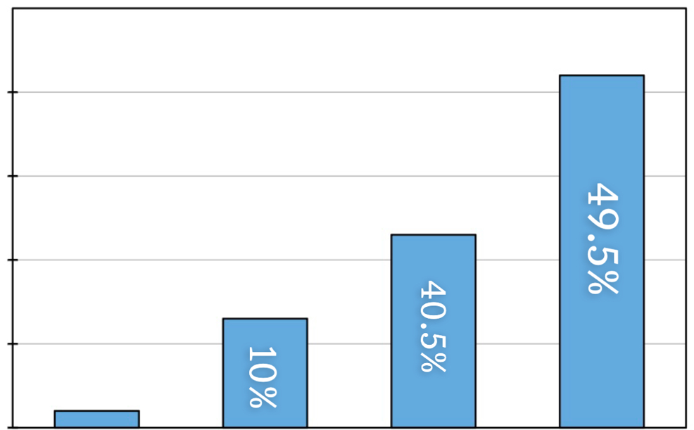

Chapter four

**Discussion**

One of the objectives of this study was to improve the knowledge level of nurses.

The average age of the participating nurses was 35 (87.5%), i.e. most were young, aged 26–30 years, and the gender of the nurses was mostly male (57.5% and 42.5%) being female. The average knowledge level of the nurses was 11/15, which is 73.33%, which means that their knowledge level was good. The average work experience was 14, which is 35%, which means that the knowledge level of the nurses was good according to their average years of experience.

**Chapter five**

**5.1 conclusion**

* The average knowledge of nurses about lung cancer was (11/15)73.33%
* The average age of nurses was 35 (87.5%)
* The average Years Of Experience nurses was 14 (35%)
* The average males of nurses was (57.7%)
* and the average female of nurses was (42.5%)

**5.2 recommendation**

1. We recommend that nurses read more about lung cancer and spread information and awareness in the community.
2. To raise nurses' awareness about lung cancer, the government and the Ministry of Health should organize annual seminars and medical conferences for nurses in lung cancer treatment centers and medical colleges and institutes, and encourage nurses to learn more about the diagnosis and causes of the disease They should be encouraged to provide more information to patients about how to deal with the disease and preventive measures.
3. Due to our time constraint we select only 40 samples from two hospitals and hence we could not scientifically analyze the relationship between participants’ knowledge and their educational level and other variables, so we recommend this future study with more samples from… more hospitals and more participant rates as well We recommend using multiple choice questions in the questionnaire

**Questionnaire**

*Thank you for agreeing to participate in this research.*

*Please answer these questions.*

**Part one :**Data collection

Age :

Gender:

nurse's qualifications:

Works place:-

years of experience :

Material status :

**Part two:** Nurse information about lung cancer

Answer these questions by **true** or **False.**

|  |  |  |
| --- | --- | --- |
| **No:** | **True** | **False** |
| **1** |  |  |
| **2** |  |  |
| **3** |  |  |
| **4** |  |  |

1. Cough is sometimes a sign of lung cancer.

2. Lung cancer can spread to other parts of the body.

3. Symptoms appear early in lung cancer.

4. Shortness of breath is a symptom of lung cancer.

|  |  |  |
| --- | --- | --- |
| **No:** | **True** | **False** |
| **5** |  |  |
| **6** |  |  |
| **7** |  |  |
| **8** |  |  |
| **9** |  |  |
| **10** |  |  |
| **11** |  |  |
| **12** |  |  |
| **13** |  |  |
| **14** |  |  |
| **15** |  |  |

5. Smoking is a cause of lung cancer.

6. Lung cancer cannot be diagnosed by x-rays.

7 . Small cell lung cancer requires surgery for treatment.

8 . Chemotherapy is a cure for lung cancer.

9. The treatment of lung cancer depends on the type

and stage of the cancer.

10 . The nurse should encourage the client to conserve

energy by reducing activity.

11. The nurse should provide a humidifier or evaporator.

12. All types of lung cancer can be prevented.

13 . Lung cancer is non- communicable disease.

14 .Only the older people get lung cancer.

15. Lung cancer is asymptomatic.

**Reference**

1. <https://www.cdc.gov/cancer/lung/basic_info/what-is-lung-cancer.htm>
2. <https://www.lung.org/lung-health-diseases/lung-disease-lookup/lung-cancer/basics>
3. <https://www.cdc.gov/cancer/lung/basic_info/index.htm>
4. <https://www.cdc.gov/cancer/lung/basic_info/what-is-lung-cancer.htm>
5. <https://www.mayoclinic.org/diseases-conditions/lung-cancer/symptoms-causes/syc-20374620>
6. <https://moffitt.org/cancers/lung-cancer/faqs/how-fast-can-lung-cancer-spread/#:~:text=Where%20does%20lung%20cancer%20spread,brain%2C%20bones%20or%20adrenal%20glands>.
7. <https://www.cdc.gov/cancer/lung/basic_info/risk_factors.htm>
8. <https://amp.cancer.org/cancer/lung-cancer/causes-risks-prevention/prevention.html>
9. <https://nursestudy.net/lung-cancer-nursing-diagnosis/>
10. <https://www.cdc.gov/cancer/lung/basic_info/diagnosis_treatment.htm>
11. <https://www.cdc.gov/cancer/lung/basic_info/diagnosis_treatment.htm>
12. <https://www.rnpedia.com/nursing-notes/medical-surgical-nursing-notes/lung-cancer/>

**پوخـــــتە**

شێرپەنجەی سییەکان نەخۆشییەکە کە گەشەی خانەکانی سییەکان لە کۆنتڕۆڵ دەردەچێت. شێرپەنجەی سییەکان سەرەتا بێ نیشانەیە و دواتر چەند نیشانەیەکی نیشان دەدات. شێرپەنجەی سییەکان دووهەمین شێرپەنجەی باوە لە پیاوان و ئافرەتان لە ئەمریکا. شێرپەنجەی سییەکان دەتوانرێت بە نەشتەرگەری، چارەسەری تیشکی، چارەسەری کیمیایی و هیتر ... چارەسەر بکرێت بەپێی جۆری خانە شێرپەنجەییەکان. لە ڕێگەی ڕاپرسییەکەوە کە پێکهاتووە لە ١٥ پرسیار و زانیاری کەسی کە ئاڕاستەی ٤٠ پەرستارمان کرد لە نەخۆشخانەکانی هەولێر، هەڵسەنگاندن بۆ زانیاری پەرستارانی هەولێر دەکەین لەسەر ئەم بابەتە، بۆ دیاریکردنی ئاستی زانیاری پەرستارەکانمان و هۆشیارکردنەوەی خەڵک سەبارەت بە شێرپەنجەی سییەکان. لە ئەنجامی توێژینەوەکەدا بۆمان دەرکەوتووە کە پەرستارانی شاری هەولێر زانیارییەکی باشیان هەیە لەسەر شێرپەنجەی سییەکان.

**الخلا صة**

سرطان الرئة هو مرض يخرج فيه نمو خلايا الرئة عن السيطرة. سرطان الرئة عديم الأعراض في البداية ، ثم تظهر عدة أعراض. يعد سرطان الرئة ثاني أكثر أنواع السرطانات شيوعًا بين الرجال والنساء في الولايات المتحدة. يمكن علاج سرطان الرئة بالجراحة والعلاج الإشعاعي والعلاج الكيميائي وما إلى ذلك ، حسب نوع الخلايا السرطانية. من خلال استبيان يتكون من 15 سؤالاً ومعلومات شخصية وجهناها إلى 40 ممرضاً في مستشفيات أربيل ، سنقوم بتقييم معرفة ممرضات أربيل حول هذا الموضوع ، لتحديد مستوى معرفة الممرضات لدينا ولزيادة الوعي حول سرطان الرئة. نتيجة للدراسة وجدنا أن الممرضات في أربيل لديهم معرفة جيدة بسرطان الرئة..



وەزارەتی خوێندنی باڵاو توێژینەوەی زانستی

زانکۆی پۆلیتەکنیکی هەولێر

کۆلێژی تەکنیکی شەقڵاوە

بەشی پەرستاری

زانکۆیپۆلیتەکنیکیهەولێر

کۆلێژیتەکنیکیشەقڵاوە

بەشیپەرستاری

پڕۆژەی دەرچوون (لێکۆڵینەوە) بۆکۆلێژی تەکنیکی شەقڵاوە

دەربارەی ئاستی زانیاری پەرستاران لەسەرشێرپەنجەی سییەکان لە نەخۆشخانەکانی هەولێر.

ئامادەکردنی:

زێلان ادریس

سەروین غفور

سارا رەسول

فاتیمە صابر

سەرپەرشتیکراوە لەلایەن:

م.دلێرمحەمەد

(2022-2023)