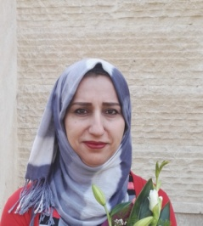

Personal Information

Name: Cheman Baker Ismael
Date and place of birth: 3/3 1970 Iraq/Erbil
Home address: Erbil/ shorish
Mob. No. : 07504555916
E-mail: chemanhema@yahoo.com
(EPU email): chemanbi@epu.edu.krd
Job title: Lecturer
Date of first assignment in University: 15/11/1992
Place of recent work: Foundation of Technical Education/ Medical Technical Institute/ x-ray department.
Academic title: Lecturer
University service: 26 years. Asst.Physics in AL – Salahaddin university collage of science, physics department and medical technical institute x-ray department/ erbil
Language: Kurdish native language
Arabic: Advanced
English: Intermediate
Turkish: Intermediate

Education
Graduated from the Physics Department in 1990-1991, Faculty of Science at the University of Salahaddin/ and awarded degree of BSC. Rank fourth over the Department grade (good).
I appointed as Physics Assistance at the same Department for 15 years. In 2005-2006 started to study Mater degree specialized in physics at the University Of Salahaddin and in the year 2007-2008 successfully completed the master grade (Very Good).
After completion of Master education I transferred my services from Salahaddin University to the Polytechnic University under the Ministry of Higher Education, Medical Technical Institute.

Experience:
- First I was an Assistance Physics at the physics department in Faculty of Science at the University of Salahaddin for 15 years
- Then Assistance teacher at the radiology department in medical technical institute at the polytechnic university since 2008.
- In the year2013 I received the post of manager of health and safety managment in Polytechnic University until April 2018 besides lecturing at radiology department.
- Now I'm lecturer at radiology department in Polytechnic University
Teaching Subjects: Radiology physics, Techniques of radiology equipment, medical physics, protection of radiation, Mathematics. Computer basic

