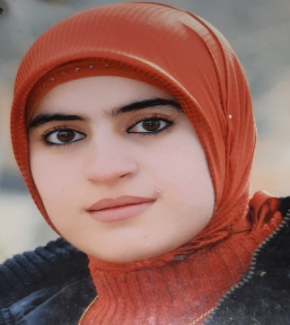
Mr. Amina Yaseen Mohammad
+9647504973862
Amina.mohammad@epu.edu.iq
Iraqi Kurdistan Region
Erbil- Daratoo 120mt Street

Objective
My goal is to serve Kurdish language and literature, together. That is why I conduct rare researches on Kurdish literature, so that we can reach a summit in Kurdish language and literature.

Skills & Abilities

I have skills in Kurdish, Arabic, English and Farsi, and they are writing a book and literary research.

Experience
I have experience in managing management and teaching a Kurdish lesson. | [Dates from] — [to]
[Job Title] — [Company Name] | [Dates from] — [to]
My job title is an assistant lecturer and a precise specialization, the Budaiya gap in the poetry of Salam poet.

Education
I have a master's degree in a technical institute, plant protection department. | [Dates from] — [to]

